Ferranti Mark I Simulator User’s Guide

31-Mar-2023

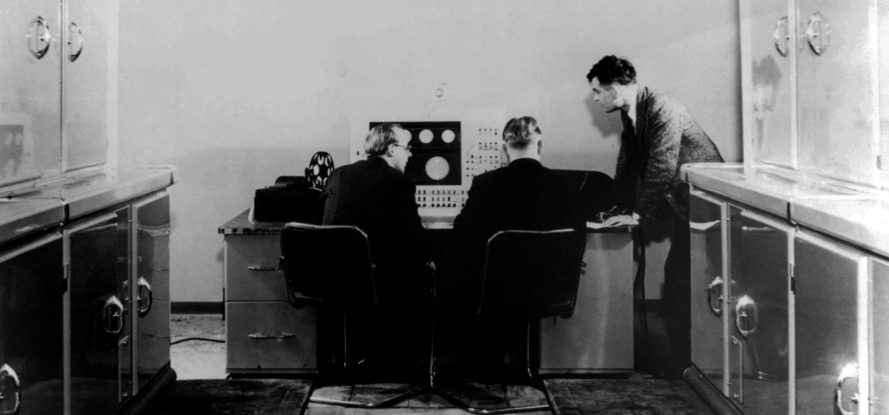

**COPYRIGHT NOTICE**

The following copyright notice applies to the SIMH source, binary, and documentation:

Original code published 1993-2012, written by Robert M Supnik  
Copyright © 1993-2012, Robert M Supnik  
Copyright © 2018-2023, Roberto Sancho

Permission is hereby granted, free of charge, to any person obtaining a copy of this soft­ware and associated documentation files (the "Software"), to deal in the Software without restriction, including without limitation the rights to use, copy, modify, merge, publish, dis­tribute, sublicense, and/or sell copies of the Software, and to permit persons to whom the Software is furnished to do so, subject to the following conditions:

The above copyright notice and this permission notice shall be included in all copies or substantial portions of the Software.

THE SOFTWARE IS PROVIDED "AS IS", WITHOUT WARRANTY OF ANY KIND, EX­PRESS OR IMPLIED, INCLUDING BUT NOT LIMITED TO THE WARRANTIES OF MER­CHANTABILITY, FITNESS FOR A PARTICULAR PURPOSE AND NONINFRINGEMENT. IN NO EVENT SHALL THE AUTHORS BE LIABLE FOR ANY CLAIM, DAMAGES OR OTHER LIABILITY, WHETHER IN AN ACTION OF CONTRACT, TORT OR OTHERWISE, ARISING FROM, OUT OF OR IN CONNECTION WITH THE SOFTWARE OR THE USE OR OTHER DEALINGS IN THE SOFTWARE.

Except as contained in this notice, the names of the authors shall not be used in advertising or otherwise to promote the sale, use, or other dealings in this Software without prior written authorization from the authors.

1 Introduction 4

1.1 The Ferranti Mark I Electronic Computer 4

1.2 Simulator Files 5

2 Simulator Features 6

2.1 Hardware-Equivalent Actions 6

2.2 Simulator Specific Commands 7

2.2.1 Symbolic Display and Entry 7

2.2.2 RESET 9

2.2.3 RUN and GO 9

2.2.4 STEP 10

2.2.5 Device Configuration 10

2.2.6 Enabling and Disabling Devices 10

2.3 Tracing Simulator Operations 10

3 Processor Device Simulations 12

3.1 Central Processing Unit 12

3.1.1 Speed 12

3.1.2 Repeatable Random 14

3.1.3 Break on Hoot 14

3.1.4 Simulate Mark I Console Keys 14

3.1.5 Simulation Stops 15

3.1.6 Tracing 16

3.1.7 Registers 17

3.2 Drum 17

3.3 Paper Tape Reader / Punch 17

3.4 TelePrinter 18

3.5 Program Tape Preparation 19

3.5.1 Perforator commands 19

3.5.2 Coding Sheets 20

3.5.3 LOAD command 22

3.5.4 Brooker Autocode Programmes 22

3.5.5 FEEDPTR command 24

3.5.6 APPENDTOTAPE command 25

3.6 Software Support 26

4 Simulator Usage 29

4.1 Run a Program using Scheme A 29

4.2 Run a Program using Autocode 31

4.3 Available Software 33

4.3.1 Scheme A 33

4.3.2 Scheme B 33

4.3.3 Scheme C 33

4.3.4 Scheme T 34

4.3.5 Love Letters 34

4.3.6 Draughts 34

4.3.7 Brooker_Autocode 34

4.4 File extensions 35

5 Control Panel 36

5.1 Introduction 36

5.2 Available Control Panels 37

5.3 Control Panel size and position 40

5.4 Control Panel HotKeys 40

5.4.1 Control T – Toggle Marks 41

5.4.2 Control I – Show Information Panel 41

5.4.3 Control F – Fast Mode 42

5.5 Control Panel usage 43

5.6 Interactive Mode 45

5.7 Drag and Drop files 45

5.8 Detach tape file 46

5.1 Dark Mode 47

5.1 Store Selection 47

5.2 Additional comments 48

5.2.1 Speed Measurement 48

6 Control Panel usage 49

6.1 Mark I Console 49

6.1.1 Scope Tubes 49

6.1.2 Store Display Selection 49

6.1.3 Indicator lights 50

6.1.4 Input/Output control 50

6.1.5 Execution control 50

6.1.6 Hand Switches 51

6.1.7 Clearing Keys 51

6.1.8 Instruction execution keys 52

6.1.9 Type-Writer keys 52

6.2 How To … 53

6.2.1 Reboot Scheme A 53

6.2.2 Resume from Stop 54

6.2.3 Step a program 54

6.2.4 Modify a memory word (method 1) 54

6.2.5 Modify a memory word (method 2) 54

6.2.6 Manual print on TelePrinter using its keyboard 55

6.2.7 Print a paper tape on TelePrinter 55

6.2.8 Read a Track from Drum to Memory Store 55

6.2.9 Write Memory Store to Drum Track 55

6.2.10 Run Love Letters program 56

6.2.11 Run Draughts Game program 57

6.2.12 Run an Autocode program 59

6.2.13 Run HelloWord Scheme A program 60

6.2.14 Programs to Run 63

7 Version History 64

# Introduction

This manual documents the features and operation of the Ferranti Mark I simulator. It is intended for use in conjunction with the *SIMH Users' Guide* manual, which describes how to compile and run the simulator, as well as the general commands that may be entered at the Simulation Control Program (SCP) prompt.

## The Ferranti Mark I Electronic Computer

The Ferranti Mark I was produced by British electrical engineering firm Ferranti Ltd. It was the world's first commercially available general-purpose digital computer. It was installed in Manchester University in July 1951, and sold to Toronto University in January 1951.

Only two units were produced. Ferranti evolved the design into Ferranti Mark I* (Mark I star).

Mark I is a vacuum tube machine. Each machine word is composed of 40 bits. It is a binary machine. Memory was implemented using Williams tube CRT.

The CPU frequency is 100KHz (10 usec period, called digit period). The CPU is serial, it works on 24-digit period called a beat. Any instruction takes a given number of beats.

## Simulator Files

The simulator sources are divided into a set of files for the Simulator Control Program and its support libraries, and a set of files for the Mark I CPU and device simulations; the latter reside in a subdirectory of the directory that contains the SCP files. The former set is common to all SIMH simulators, whereas the latter set is specific to the virtual machine being simulated. The files that make up this simulator are:

| ***Subdirectory*** | ***File*** | ***Contains*** |
| --- | --- | --- |
| **MarkI** | MarkI_defs.h | System architectural declarations |
|  | MarkI_sys.c | SCP interface |
|  | MarkI_cpu.c | Main CPU simulator |
|  | MarkI_iodev.c | I/O devices simulation |
|  | MarkI_cpanel.c | Mark I Control Panel |
|  | cpanel.c | Control Panel interface |
|  | cpanel.h | Control Panel declarations |
|  | cpanel_vid.c | Control Panel video interface |
|  | cpanel_vid.c | Control Panel video declarations |
|  | MarkI_doc.doc | Documentation (this file) |
| **MarkI / cpanel** |  | Contains the control panel image bitmaps |
| **MarkI / test** |  | Contains the simulator test suite |
| **MarkI / sw** |  | Contains the included software and test run script files (See usage section) |

PDF files that documents the original hardware are available in

* First Edition of Programmers' handbook, by Alan Turing
  + The Alan Turing Archive: Reference AMT/B/32
  + Programmers' handbook for Manchester electronic computer. Mark II with errata sheets 28 Mar. and 9 Jul. 1951, and Programme sheets, 1951.
  + URL: <https://turingarchive.kings.cam.ac.uk/publications-lectures-and-talks-amtb/amt-b-32>
* Second Edition of Programmers' handbook, by R.A.Brooker
  + Computer History Museum: Catalog Number 102724593
  + Ferranti Mark I Programming Manual, second edition
  + URL: <https://archive.computerhistory.org/resources/access/text/2016/06/102724593-05-01-acc.pdf>
* Third Edition of Programmers' handbook, by R.A.Brooker
  + Bodleian Libraries: Shelfmark MS. Eng. misc. b. 260/C.41
  + Programmers' Handbook (Third Edition) for the Mark II, 1952-1953
  + URL: <https://archives.bodleian.ox.ac.uk/repositories/2/archival_objects/29046/>
* Introduction to programming on the Manchester Electronic Digital Computer
  + The Turing Archive for the History of Computing
  + Introduction to programming on the Manchester Electronic Digital Computer, by D.G. Prinz, Dr. phil.
  + URL: <http://www.alanturing.net/turing_archive/archive/m/m11/m11.php>

# Simulator Features

The Ferranti Mark I simulator contains the following device simulations:

| ***Device Name(s)*** | ***Simulates*** |
| --- | --- |
| **CPU** | Ferranti Mark I Electronic Computer  8 x 64 word Store Tubes |
|  |  |
| **DRUM** | 256 track drum storage, or 128 words each |
| **PTR** | Ferranti Paper Tape Reader |
| **PTP** | Ferranti Paper Tape Punch |
| **LPT** | Creed 7B TelePrinter |
| **PERFORATOR** | Creed 7P or 6S Perforator |

The simulator has been tested with and supports the following original software:

* Scheme A, Scheme B, Scheme C, Scheme T
* Scheme B FloatCode
* Draughts and Love letters programme
* R.A. Brooker Autocode

The simulator also provides extensive facilities for tracing CPU and I/O device operations.

## Hardware-Equivalent Actions

To use simulated Ferranti Mark I two interfaces are available

1. Commands that can be entered through the SimH console at sim> prompt
2. Pressing buttons and moving switches on simulation control panel GUI: the Mark I console.

To avoid ambiguity, on this document the following convention is used

* *SimH console*: when referring to Host Computer text console where SimH simulator is being run.
* Mark I console: when referring to real HW physical console simulated as a control panel displayed in a GUI window

The following table describes the SCP commands and their equivalent action on real hardware. For control panel actions, see the Control Panel section on this manual.

| ***Real Hardware Mark I Console Action*** | ***Equivalent Simulation Command in SimH console*** |
| --- | --- |
| Set Hand Switches | DEPOSIT H <value> |
| Operate (press down the switch to activate it, then release it to return to up inactive position) the KAC and KEC key-switches | SET CPU KAC  SET CPU KEC |
| Activate (switch at down position) or Deactivate (switch at up position) dummy stop switch /L and /G | SET CPU STOP=[/G][/L] | none |
| Select the Store Tubes to be visible on the main console | SET CPU DISPLAYTUBE=Sn/Sm |
| Display Accumulator register | EXAMINE AL  EXAMINE AM |
| Display C and D register | EXAMINE C  EXAMINE D |
| Display B index registers | EXAMINE B0 .. B1 |
| Activate Main prepulse switch | GO |
| De-activate Main prepulse switch | ^E on console |

Mounting media on a peripheral device is simulated by the ATTACH command. For example, entering the ATTACH PTR <paper-tape-image-filename> command is equivalent to loading the paper tape into the reader.

## Simulator Specific Commands

In general, all of the commands documented in the *SIMH Users' Guide* manual are available for use with the Ferranti Mark I. Commands whose execution or parameters are implementation-defined are specified below.

### Symbolic Display and Entry

When examining or depositing into memory, command line options specifying the symbolic mode and format may be used to override the default mode, as follows:

| ***option*** | ***Mode Interpretation on EXAMINE*** |
| --- | --- |
| **–B** | 20 bit line shown as backwards Binary |
| **–T** | 20 bit line shown as four TelePrinter characters |
| **–M** | 20 bit line shown as machine instruction |
| **–S** | 20 bit line shown as signed decimal integer (-524288 .. +524287) |
| **(none)** | 20 bit line shown as unsigned decimal integer (0..1048575) |

| ***option*** | ***Mode Interpretation on DEPOSIT*** |
| --- | --- |
| **–B** | 20 bit line shown as backwards Binary |
| **–T** | 20 bit line shown as four TelePrinter characters |
| **(none)** | 20 bit line shown as decimal integer (-524288 .. 1048575) |

If the –M option is specified, the value is displayed as a CPU machine instruction, as described in the programmer handbook Manual. Note that there is no opcode names, each instruction gest a description and/or a descriptive equation. You can examine as –M, but you cannot deposit values with –M

The ***–B*** option allows to display line contents (or enter value in a line) as *backwards binary*: this is Least Significant bit is leftmost one, Most significant bit is rightmost one. This is the reverse of modern convention on ordering the bits. Note that in backwards binary, a number is negative if the rightmost bit is one.

The ***–T*** option allows to display line contents (or enter value in a line) as four TelePrinter characters. Each TelePrinter character represents 5 bits:

|  |  |  |  |  |  |  |
| --- | --- | --- | --- | --- | --- | --- |
| TelePrinter  Character | Decimal  Value | Backwards  Binary value |  | TelePrinter  Character | Decimal  Value | Backwards  Binary value |
| /  E  @  A | 0  1  2  3 | 00000  10000  01000  11000 |  | T  Z  L  W | 16  17  18  19 | 00001  10001  01001  11001 |
| :  S  I  U | 4  5  6  7 | 00100  10100  01100  11100 |  | H  Y  P  Q | 20  21  22  23 | 00101  10101  01101  11101 |
| #  D  R  J | 8  9  10  11 | 00010  10010  01010  11010 |  | O  B  G  " | 24  25  26  27 | 00011  10011  01011  11011 |
| N  F  C  K | 12  13  14  15 | 00110  10110  01110  11110 |  | M  X  V  $ | 28  29  30  31 | 00111  10111  01111  11111 |

On Ferranti Mark I original TelePrinter character set, there are chars that does not have plain ASCII equivalent. These are pound (£) and half (½) chars. Instead of entering the deep waters of Unicode usage, this simulator replaces them with standard chars as follows

|  |  |  |  |
| --- | --- | --- | --- |
| Original  HW TelePrinter  Character (as seen in original doc) | Decimal  Value | Backwards  Binary value | SimH equivalent character to be used |
| ½  £ | 8  31 | 00010  11111 | #  $ |

The ***–S*** option allows to display line contents as signed decimal value (two complement) in range -524288 .. +524287. If no option is given, the line is displayed as unsigned decimal value in range 0..1048575. On deposit command, if no option is given, the line can be set to a given decimal value in range -524288 .. 1048575.

Note that on ***DEPOSIT*** and ***EXAMINE*** commands, the memory line to use is always given as an unsigned decimal value in range 0..511

Examples

sim> deposit -b 100 00000 01000 00100 00010

examine –b 100

100: 00000 01000 00100 00010

examine –t 100

100: /@:#

deposit -t 100 ABCX

examine -b 100

100: 11000 10011 01110 10111 rightmost bit is 1 -> negative number

examine -t 100

100: ABCX

examine –s 100 examine as signed integer

100: -83165

examine 100 examine as unsigned integer

100: 965411

dep 100 -1

ex -s 100 examine as signed

100: -1

ex 100

100: 1048575 as unsigned

dep 100 1000000

ex 100

100: 1000000

ex -s 100

100: -48576

ex -m 180-185

180: #@QO (addr=0072 B7 func=TO) B=S (no B addition)

181: DE@/ (addr=0041 B2 func=//) H as magnetic instr

182: #@QO (addr=0072 B7 func=TO) B=S (no B addition)

183: :@@/ (addr=0068 B2 func=//) H as magnetic instr

184: U@// (addr=0071 func=//) H as magnetic instr

185: W/E@ (addr=0019 B1 func=/@) Standarise

### RESET

The RESET command is equivalent in hardware to operating the KEC (Key Everything clear) switch in Mark I console.

### RUN and GO

The RUN and GO commands do not accept any parameter addresses. Execution will start at the address specified by the IC register.

The RUN command does an implied RESET, so it is equivalent to operating the Mark I console KEC switch, then the MAIN-PREPULSE switch to start full speed execution of programme. Reset set the CPU so the first action will be to increment C, then fetch the first machine instruction to execute (i.e. from address 0001), as expected by programs.

The GO command is equivalent to operate the MAIN-PREPULSE switch to start full speed execution of programme, without resetting the CPU. This is used to resume execution after a CPU halt.

### STEP

The ***STEP*** command is used to execute program instructions on a one by one basis.

By default, when the simulator steps, it executes a full instruction cycle, increments C register and then stops (at beginning of scan beat).

Some instructions can halt in its execution (at beginning of execution beat)

/L and /G dummy stop

Paper tape read without paper tape file attached

In this case, the execution is stopped before C is incremented. In this case, ***STEP*** will execute again the offending instruction, which will stop again if stop condition is met. If stop condition is not met (e.g. dummy stop switch set in inactive position or paper tape attached to reader), ***STEP*** will make the machine instruction to finish its execution, C incremented, and CPU is stopped.

When the user issues a ***DEPOSIT C*** command to set the Control register, the CPU is set to fetch beat. So the next ***GO/STEP*** command will read the C register value and the fetch its instruction into PI (Program Instruction register) and the execute it.

When the user issues a ***DEPOSIT PI*** command to set the Program Instruction Register, the CPU is set to execution beat. So the next ***GO/STEP*** command will read the PI register value just set and execute it.

### Device Configuration

Most devices support user configuration. The general forms of the configuration commands are:

***SET [<option> ...} <device> <option> [,<option> ..]  
SET [<option> ...] <unit> <option> [,<option> ...]***

The options available are described in the individual device descriptions below.

### Enabling and Disabling Devices

All devices other than the CPU, may be disabled or enabled. Disabling a device simulates deactivating the associated equipment on the Mark I console. To disable or enable a device, use:

| ***Command*** | ***Action*** |
| --- | --- |
| **SET <device> DISABLED** | Disable the device |
| **SET <device> ENABLED** | Enable the device |

PTR (Paper Tape reader), PTP (paper tape Punch) and LPT (TelePrinter) are enabled by default. DRUM and PERFORATOR devices cannot be disabled

## Tracing Simulator Operations

The simulator provides options for extensive tracing of the internal operations of selected devices. This is useful as an aid to hardware and software debugging as well as to gain an understanding of the internal operations of the simulated devices. Devices offer multiple trace reporting levels, from command overviews to detailed operation. Tracing for each device and its separate reporting levels may be enabled independently.

To obtain a trace, two SCP commands must be given.

First, a *debug log* must be established with the SET DEBUG <target> command. This command is described in detail in the “Controlling Debugging” section of the *SIMH Users' Guide* manual. The target can be a text file, so that the trace may be reviewed after capture, or stdout to display the trace data on SimH console as it is generated.

Second, tracing must be enabled for the desired devices with SET <device> DEBUG=<option> commands. The formats of the trace outputs are specific to the devices being traced. All traces for a device can be enabled at once with a SET <device> DEBUG command.

Tracing does impose some overhead on the simulator, with more detailed tracing slowing the simulator more than higher-level tracing. No overhead is incurred when tracing is suspended with the SET NODEBUG command, even if individual device tracing options remain in effect.

When all the debug traces are set, a sensible overhead is produced, and a very big debug file is generated (as much as 20 MB per minute)

# Processor Device Simulations

## Central Processing Unit

The Ferranti Mark I CPU is configured with commands of the form:

***SET CPU <option>***

Device options that may be specified are:

| ***Option*** | ***Action*** |
| --- | --- |
| **DEBUG=<option>** | Enable tracing |
| **NODEBUG** | Disable tracing (default) |
| **TRUE_RANDOM** | /W instr returns random values sequences |
| **REPEATABLE_RANDOM** | /W Always return the same sequence of numbers |
| **NOBRKHOOT** | Do not halt CPU on /V hoot instruction |
| **BRKHOOT** | Halt CPU on /V hoot instruction |
| **KEC** | Operate KEC switch |
| **KAC** | Operate KAC switch |
| **STOP** | Set Dummy Stop switches |
| **DISPLAY** | Set Storage tubes visible on Mark I console |
| **FAST** | Execute all instructions in one beat |
| **REALTIME** | Simulate real number of beats (default) |
| **SPEED** | Set simulated CPU speed |

The command

***RESET CPU***

Will do the following actions:

* Clear all memory (set to zero value)
* Clear A (AM and AL), B (B0 to B7), C (including PI), D registers
* Clear D-sign and Q-negative bits
* Set CPU so next instr starts by incrementing C before fetching next instr
* Reset TelePrinter to letter Shift position (this is not realistic but handily to guarantee the initial setting for printing)

### Speed

The CPU frequency is 100KHz (10 usec period, called digit period). The CPU is serial, it works on 24-digit period called a beat. Any instruction takes a given number of beats.

Most instructions needs 4 beats to execute. Multiplication 9 beats, arithmetic and logic needs 5 beats. On real hardware, the average execution speed is around 800-900 instructions per second (IPS).

Nevertheless, achieved IPS can be lower, mainly because the wait introduced by I/O, when an IO instruction is waiting for the device

The user can disable the simulation of execution time, so all instructions will need only one beat to execute.

***SET CPU FAST*** each instruction needs only one beat time to execute

***SET CPU REALTIME*** simulate real number of beat needed by instruction

to execute (default)

To allow setting the simulated CPU speed with accuracy when Control Panel GUI is active, a new SCP command is defined;

***SET CPU SPEED=n.n*** Set the simulated CPU speed to n.n times the speed of real hardware (i.e speed is relative to original Ferranti Mark I speed)

Depending on n.n value, it is possible to set the simulated speed. If n.n is …

1. Set simulated speed to be the same as in real hardware (4166 beats per second)

2.0 Set to double of real hardware speed

0.5 Set to half of real hardware speed

Up to two decimal digits are permitted. Value 0.0 is not allowed. Range goes from as low as 0.01 (one hundred times slower) to 100.0 (100 times faster).

At the minimum speed allowed (Speed=0.01, 100 times slower), the simulated CPU executes 41 beats per second, approx. 10 instructions per second.

Maximum speed is set using the form

***SET CPU SPEED=MAX*** Simulated CPU runs al maximum speed allowed by host

The current value of speed setting can be show using the command

***SHOW CPU SPEED*** Display Speed relative to original hardware, the number of Instructions executed per second. Will also show the elapsed time CPU has been running. All of these figures are wall clock time

Example output:

Measured speed: Speed is x1.0 relative to original hardware

785 Instructions per second (IPS) achieved

run elapsed 23.5 sec (23546 msec)

The measurements are done taking into account the total number of beats and instructions executed in the last run. On this context last run is time elapsing between CPU started (either by a ***GO*** or ***RUN*** SCP command), until CPU is stopped and control returned to SCP (either to continue a script execution or to command prompt)

If no data measured (not run yet, executing step by step) the SCP command ***SHOW CPU SPEED*** will only display first output line indicating the speed setting.

On startup, the simulator defaults to MAX speed.

### Repeatable Random

Ferranti Mark I has an instruction /W to generate a random value in accumulator

The SCP command ***SET CPU TRUE_RANDOM*** will instruct the simulator to generate true random numbers, and also to use a random sequence of numbers

On the contrary, ***SET CPU REPEATABLE_RANDOM*** will instruct the simulator to generate random numbers but always on same sequence. The sequence starts on each ***GO/STEP*** command. This is very handy on debugging programs that uses the /W instruction.

### Break on Hoot

On real HW, The audible hoot generated by /V instruction is used to signal some condition to user, in general the presence of an error.

The SCP command ***SET CPU BRKHOOT*** will instruct the simulator to halt the CPU on /V instruction.

The command ***SET CPU NOBRKHOOT*** allows simulation to run even if /V is executed. Note that if /V is executed on a tight endless loop (to produce what is called a *continuous hoot* in programmers handbook), the execution will HALT regardless this setting

### Simulate Mark I Console Keys

On real HW, Mark I console plays an important role on executing the programmes. When using GUI control panel, the console is simulated, so the user can use the console switches and buttons.

On scripts (or when Mark I console GUI not visible) some of the switches operation can be simulated with SCP commands:

***SET CPU KEC*** Operate the Everything Clear Key (KEC). Same as effect as ***RESET*** command

***SET CPU KAC*** Operate the Accumulator Clear Key (KAC). Clears the 80 bits accumulator.

CPU has two instructions (/L and /G) that will stop or continue depending on the state of Dummy Stop switches on real HW Mark I Console.

* If Switch is not active, the CPU will interpret the instruction as no operation.
* If Switch is active, the CPU will halt on instruction. Then use SCP command ***GO/STEP*** to resume, or operate the KCS Mark I console switch.

On scripts (or when console GUI not visible) the dummy stop Mark I console switches operation can be simulated with SCP commands:

***SET CPU STOP* =** [**/G**][**/L**] | **none** | **<none>**

Examples:

***SET CPU STOP* = /G** activate Dummy Stop on /G instr

(CPU will halt on /G instr)

***SET CPU STOP* = /L** activate Dummy Stop on /L instr

(CPU will halt on /L instr)

***SET CPU STOP* = /L/G** activate Dummy Stop on /L and /G instr

(CPU will halt on both)

***SET CPU STOP* = *none*** de-activate Dummy Stop on /L and /G instr

(CPU will not halt on any)

***SET CPU STOP = <none>*** same as above

When console GUI is visible, it is handy to be able to script the visible Store Tubes. This can be done with SCP command

***SET CPU DISPLAY = S***n***/S***m Left tube will show Store n, Right one Store m

n and m are numbers in range 0..7

Example

***SET CPU DISPLAY = S0/S4*** Left tube will show Store 0, Right one Store 4

### Simulation Stops

The Ferranti Mark I simulator implements several unique stop conditions:

Unknown error

Program Stop

Host I/O Error

Unknown Opcode

PaperTape EOF

No Tape in PTR

Continuous Hoot

Dynamic Stop

Transfer to //// instruction

On real HW, only stop condition implemented is “Program Stop”. It is triggered by /L or /G instructions when corresponding Dummy Stop Switch is active

For convenience and ease of use, additional stop conditions have been implemented. These stop conditions, when met halts the CPU. Simulator returns to sim> prompt or continue the execution of current running script, if any

|  |  |
| --- | --- |
| Stop condition | Comment |
| Unknown error | Should never happen! (hope so) |
| Program Stop | Triggered by /L and /G when corresponding switch active |
| Host I/O Error | Triggered on host I/O error on reading PTR paper tape file, reading or writing to DRUM file, writing to PTP paper tape file, writing to LPT file.  On real HW there is no concept of I/O error. The machine just locks/gets foul |
| Unknown Opcode | Triggered when executing an unofficial opcode.  On real HW there is no unknown opcode error. The machine just locks/gets foul/does something strange |

|  |  |
| --- | --- |
| PaperTape EOF | Triggered when Paper Tape File being read on PTR hits its end of file.  Programmer’s Handbook does not states what happens when reader runs out of paper tape input. It is probable that the CPU just freezes waiting for input.  A stop condition has been implemented in simulator for ease of use and ease of scripting |
| No Tape in PTR | Triggered when reading from PTR but no Paper Tape File attached to it.  Programmer’s Handbook does not states what happens when reading without paper tape on reader. It is probable that the CPU just freezes waiting for input.  A stop condition has been implemented in simulator for ease of use and ease of scripting |
| Continuous Hoot | It is a common practice to signal a fatal program error to user by entering a tight endless loop that makes an audible hoot. The user should then stop the CPU and fix the offending program. This is called a “continuous hoot” in Programmer’s Handbook.  If continuous hoot condition is detected by simulation then CPU stops. |
| Dynamic Stop | It is a common practice to signal end of program to user by entering an endless loop. The user should then stop the CPU and perform some action. This is called a “dynamic stop” in Programmer’s Handbook.  If Dynamic stop condition is detected by simulation then CPU stops. |
| Transfer to //// instruction | Sometimes program goes wrong and loads and empty track instead of the expected routine code from drum. In this case, on entering loaded empty routine, the //// instruction will be executed.  On real HW, this will produce unpredictable results based on current state of hand switches, current contents of drum.  If this condition is detected by simulation then CPU stops |

### Tracing

When a debug log has been established, tracing may be configured by specifying one or more of the reporting level options:

| ***Option*** | ***Reporting Level*** |
| --- | --- |
| **CMD** | Instruction/command executed |
| **DATA** | Memory data accesses |
| **DETAIL** | Detail of operation |
| **EXP** | More detail of operation |

### Registers

The CPU state contains the registers visible to the programmer (either on code or thru the Mark I console):

| ***Name*** | ***Size*** | ***Description*** |
| --- | --- | --- |
| **AL** | 40 | Accumulator (least significant part) |
| **AM** | 40 | Accumulator (most significant part) |
| **B0** to **B7** | 20 | B-index registers |
| **C** | 10 | Control |
| **D** | 40 | Multiplier-Quotient Register |
| **PI** | 20 | Program Instruction Register |
| **H** | 20 | Hand Switch |

Size is given in bits. Format is two complement

In addition, these pseudo register are implemented in simulator for convenience

| ***Name*** | ***Size*** | ***Description*** |
| --- | --- | --- |
| **CPANELGUI** | 1 | Returns 0 if simulator is compiled without Control Panel GUI. Returns 1 if simulator supports Control Panel |

These pseudo registers does not exists in real hardware, but are useful for SCP scripting.

## Drum

Ferranti Mark I uses as secondary storage a magnetic drum with capacity of 256 tracks, each of 128 words.

Drum is simulated with a binary file, which can be attached

***ATTACH DRUM <file>*** use an existing drum file

***ATTACH DRUM –N <file>*** create a new blankdrum file

Drum file is updated on each write track magnetic instruction executed by CPU. Drum file is closed either by quitting the simulation (***QUIT*** or ***BYE*** SCP command) or by ***DETTACH DRUM*** command.

It is possible to make the drum to not update the file in disk (drum info will be updated in a memory image) so the drum is unaltered during say a demo/test run. Use the commands:

***SET DRUM NOPERSISTENT*** drum track writes occurs only in memory image

***SET DRUM PERSISTENT*** drum track writes the drum file image

## Paper Tape Reader / Punch

The Paper Tape Reader (PTR) read paper tape input to the computer. The Paper Tape Punch (PTP) generates an output paper tape from computer. Paper Tape is simulated as file with ASCII lines with terminating newlines.

The ATTACH command simulates putting a paper tape in the reader:

***ATTACH PTR <file>***

The reader gets info from in the attached file, without any visible notice. Nevertheless it is possible to display what is being read in SimH console:

***SET PTR NOECHO*** Nothing show on SimH console about file being read

***SET PTR ECHO*** Showread chars on SimH console

These options are useful to allow displaying the reading progress of a running program

The text file that simulate paper tape has the following rules

* Spaces, ASCII control chars as <CR> or <LF> are skipped
* A “;” char indicates start of comment. The “,” and following chars until the end of line are ignored
* Character set allowed is TelePrinter set, either in figure shift or letter shit. Any other character is ignored
* As spaces are ignored, when preparing a tape with numeric input, numbers should be separated either by sign (+ or -) or by char Z (TelePrinter code for space) depending on input routine used

|  |  |  |  |  |
| --- | --- | --- | --- | --- |
| Character in Paper Tape file | value read into computer |  | Character in Paper Tape file | value read into computer |
| / 0  E 1  @ 2  A 3 | 0  1  2  3 |  | T  Z  L  W | 16  17  18  19 |
| : 4  S 5  I 6  U 7 | 4  5  6  7 |  | H  Y  P +  Q = | 20  21  22  23 |
| # 8  D 9  R  J | 8  9  10  11 |  | O  B  G  " | 24  25  26  27 |
| N  F .  C  K | 12  13  14  15 |  | M -  X  V  $ | 28  29  30  31 |

Use ATTACH command to simulate putting a blank paper tape in the punch:

***ATTACH PTP <file>***

This will append punched chars to the attached file. To add a blank new file use

***ATTACH –N PTP <file>***

Punching is simulated adding a char to the paper tape file. The char added is the Letter shift TelePrinter code.

## TelePrinter

Ferranti Mark I uses a modified Creed 7B TelePrinter as printer connected to computer.

Attaching a text file to the unit simulates loading paper into the printer:

***ATTACH LPT [-N] <printoutfilename>***

Adding the **–N** (new file) option clears the contents of the image file if present. Without the –N option, printer output will be appended to any preexisting image file content.

Printer output written to the printout file is buffered by the host operating systems. Stopping the simulation flushes the file.

Printer support several options:

***SET LPT ECHO*** Echo printed lines to SimH console

***SET LPT NOECHO*** Do not echo printed lines to SimH console

***SET LPT PRINT*** Add printed line to printout file

***SET LPT NOPRINT*** Do not add printed line to printout file

Printers defaults to ECHO and PRINT

Printing with no output file attached does not produce an error,

Is LPT is disabled, no printing (not error) will occurs.

## Program Tape Preparation

The program tape preparation procedure is described in Programmer’s Handbook. This procedure involves

* An operator takes the programme (usually handwrite in several paper sheets) and punches it in an Offline perforator
* The perforator produces a punched paper tape with the programme in it
* When operator finishes typing the programme, the produced paper tape is removed from perforator.
* May be several punched paper tapes will be tied together in sequence
* The resulting paper tape will be feed later to the paper tape reader of computer

Two offline perforator devices are known to exist.

1. A standard Creed 6 perforator with keys showing the TelePrinter character set
2. A Creed 7 perforator with keys showing the Autocode character set

Depending on what is to be punched, the operator will use one or the other perforator.

This preparation procedure can be done by the simulator user editing a blank text file in host computer (with his favorite text editor, say notepad.exe) and typing-in the needed TelePrinter chars.

Additionally, Ferranti Mark I simulator provides a set of SCP commands to simulate the Creed perforators, and thus ease the program preparation.

### Perforator commands

Before using the simulated perforator, the output paper tape file must be handled

***ATTACH PERFORATOR <punched_file.txt>*** the output file that simulates paper tape

where routine is to be punched

***SET PERFORATOR ECHO | NOECHO*** see / do not see in SimH console what

is being typed on perforator

***DETTACH PERFORATOR*** flush and closes the paper tape file when programme has been processed, so it becomes ready to be attached to PTR and run in computer

To indicate what to type in perforator to be punched in output file, use

***TYPEIN*** [***-Q***] ***LINE*** [***|***] K AK KK ... [; comment]

Will add the given chars (in the example K AK …) in output file

The chars must be any PTR accepted input char. If not, an error

message is printed in SimH console (-Q option suppresses the error message)

A comment is allowed following a “;”. Both “;” and comment chars are ignored

Spaces between chars are not punched, but are printed in SimH console (if ECHO is set).

The “|” char if present is not punched, but converted to space on SimH console. It is handy to format/align the SimH console output

***TYPEIN*** [***-Q***] ***ROUTINE***[***1***..***8***]***<routine_file.txt>*** [***S4***|***S5***|...|**S**n]

Will add the given routine number from given text file. If number is omitted, ROUTINE1 will be assumed.

If any error on routine formant, an error message is printed in SimH console (-Q option suppresses the error message)

Routine is punched to be loaded in Store S4, S5 or any desired one (Sn where n is 0 to 7)

### Coding Sheets

The text routine file to be processed by **TYPEIN ROUTINE** command mimics the MANCHESTER UNIVERSITY coding sheets.

Original Program Sheet the same as a text file

Routine 1

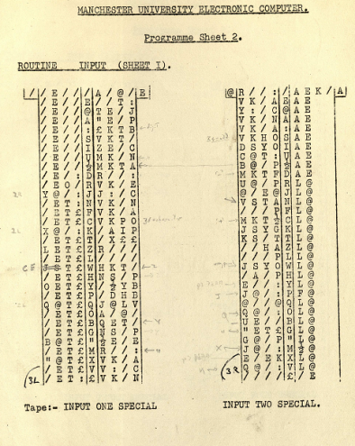 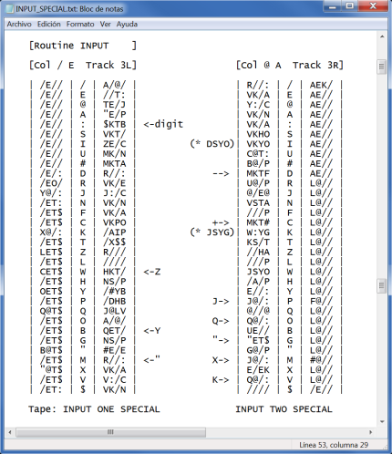 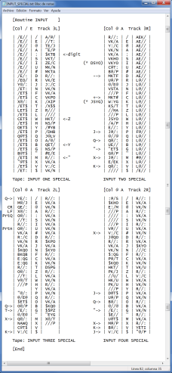

Routine 4

Routine 3

Routine 2

Routines are punched on a one by one basis. A file can hold from 1 up to 8 routines, on pairs.

Blank characters in original sheet should be written as “/” in text file.

These routines are punched on the K convention or in the J convention, depending of command

***SET PERFORATOR USE_WC_K*** | ***USE_WC_J***

Scheme A expect K or J convention, Scheme B,C,T expects only K convention (see Programmer Handbook)

This is what will be generated in paper tape file with **TYPEIN ROUTINE1** **S4** command

K/#T

/E// /E// /E// /E// /E// /E// /E// /E//

/E// /E/: /EO/ Y@/: /ET: /ET$ /ET$ X@/:

KT#T

/ET$ LET$ /ET$ CET$ /ET$ OET$ /ET$ Q@T$

/ET$ /ET$ /ET$ B@T$ /ET$ "@T$ /ET$ /ET:

K/DT

A/@/ //T: TE/J "E/P $KTB VKT/ ZE/C MK/N

MKTA R//: VK/E J:/C VK/N VK/A VKPO /AIP

KTDT

/X$$ R/// //// HKT/ NS/P /#YB /DHB J@LV

A/@/ QET/ NS/P #E/E R//: VK/A V:/C VK/N

Alternate format for coding sheets is supported (and auto detected)

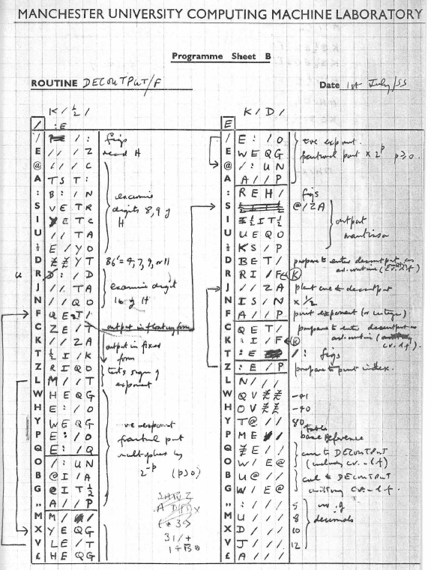 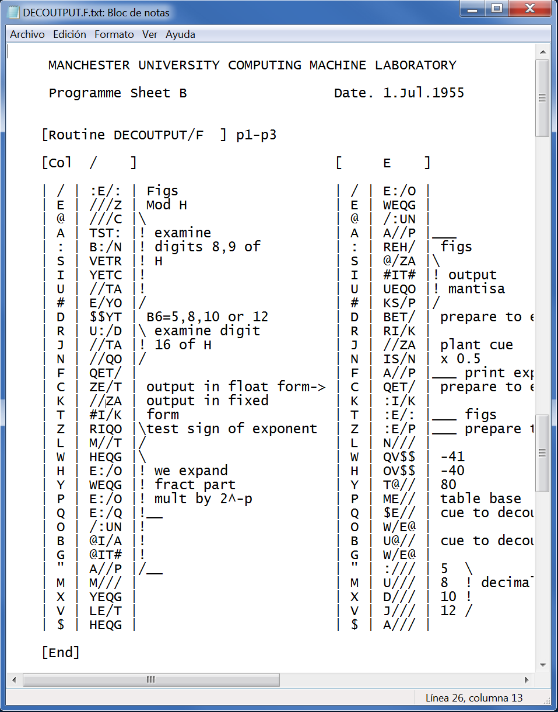

The syntax for coding routine_file.txt is the following:

* Format info is give as enclosed with [ ]. These chars should not be used elsewhere
* Chars to be punched are enclosed with |(vertical bar). This char should not be used elsewhere
* All text before [Routine ], outside [ ] and |, and after final [End] is ignored

[Routine NAME ] <--- [Command is case sensitive

[Col / E ] / and E chars signal the column.

[Col / E ] [Col @ A ] can have optionally a second pair of

Columns for routine2

[Col / E Track 3L | 3R ] and optionally a track to store routine

Via LOAD command (see later)

| //// | / | | | //// | / | AAAA | comment

| TE/: | E | YAAA | comment | //// | E | |

| L/T: | @ | I/// | ...

...

[End] <-- is optional. Only needed if later comment contains | char

comment

; comment

For alternate program sheet format, use:

[Routine NAME ] <--- [Command is case sensitive

[Col / ] / char signals the column.

[Col / ] [ E ] can have optionally a second column

for this routine

[Col / ] [ E Track 3L | 3R ] and optionally a track to store routine

Via LOAD command (see later)

| / | | | / | AAAA | comment

| E | YAAA | comment | E | BBBB |

| @ | I/// | ...

...

[End] <-- is optional. Only needed if later comment contains | char

comment

; comment

Alternate format allows only one routine per file.

Examples of routines files transcribed from original source coding sheets can be found in /Prog and /DrumIsolated folders

### LOAD command

SimH simulator also supports loading a routine directly to a given drum track, instead of being punched on perforator, the read with PTR.

Even if this is unrealistic, it is very handy for initial setup of DRUM, with start-up routines.

To load a routine in DRUM use the SCP command

***LOAD******<routine_file.txt>***

This will load the routine in indicated track

### Brooker Autocode Programmes

On real HW, Autocode programs are not perforated with standar Creed 6 device. Instead they are punches using a creed 7P perforator

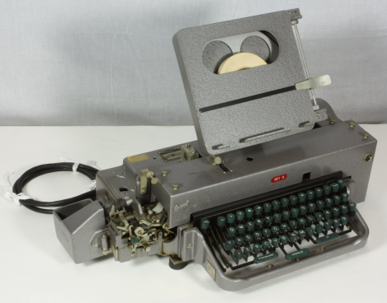

The charset that can be typed-in and thus used in source Autocode programs is very different from the one used on regular TelePrinter.

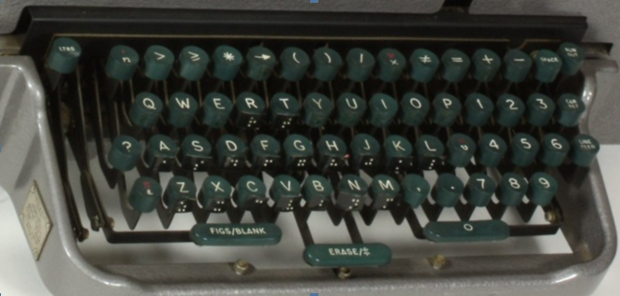

The following table indicates the 5-hole code punched for every Creed 7P character, in Letter Shift (LS) position and Figure Shift (FS) Position

|  |  |  |  |  |  |  |
| --- | --- | --- | --- | --- | --- | --- |
| Creed 7P key while in  LS FS | 5-hole code  punched | Equivalent TelePrinter  Character |  | Creed 7P key while in  LS FS | 5-hole code  punched | Equivalent TelePrinter  Character |
| FIGS FIGS  A 1  B 2  C * | 0  1  2  3 | /  E  @  A |  | P 0 (zero)  Q >  R  S 3 | 16  17  18  19 | T  Z  L  W |
| D 4  E (  F )  G 7 | 4  5  6  7 | :  S  I  U |  | T →  U 5  V 6  W / | 20  21  22  23 | H  Y  P  Q |
| H 8  I ≠  J =  K – (minus) | 8  9  10  11 | #  D  R  J |  | X x  Y 9  Z +  LTRS LTRS | 24  25  26  27 | O  B  G  " |
| L *v*  M LINE-FEED  N SPACE  O , (coma) | 12  13  14  15 | N  F  C  K |  | . . (dot)  ? *n*  $ CAR-RET  ERASE | 28  29  30  31 | M  X  V  $ |

As an example, if the user types in real Creed 7P the Autocode line

*v*1 = *v*1 + 1 <carriage return> <line feed>

The equivalent TelePrinter chars punched in paper tape are

NERNEGVF

Ferranti Mark I simulator supports loading Autocode programs via simulated Creed 7P perforator.

The source program is to be processed by **TYPEIN BAUTOCODE LINE** command or **TYPEIN BAUTOCODE SOURCE.**

***TYPEIN [-Q] BAUTOCODE LINE*** autocode_sentence [; comment]

Adds to current perforator attached text file the TelePrinter chars equivalent

To the given Autocode sentence

***TYPEIN [-Q] BAUTOCODE SOURCE* <**autocode_source_file> [; comment]

Reads the supplied text <autocode_source_file>, and for each line adds

the TelePrinter chars equivalent

On Autocode source text, spaces are ignored. “;” character indicates the start of a comment up to the end of line (which is skipped)

If a character not in Autocode charset is found, and error will be printed in SimH console (suppressed with –Q option)

On original Creed 7P character set, there are chars that does not have plain ASCII equivalent. These are greater-or-equal (), different (≠) and jump-arrow (→) chars. The simulator replaces them with standard chars as follows

|  |  |
| --- | --- |
| Original  Creed 7P  Character | SimH equivalent characters to be used |
| ≠  → | >=  !=  j |

### FEEDPTR command

Sometimes it is needed to feed some characters to Paper Tape reader, because an error for example, or to supply some missing data.

This is done in real HW by

1. Unmounting current mounted tape, if any
2. Perforating the needed sequence on a new papertape
3. Mounting the new papertape in paper tape reader

An then, when computer has read this new papertape sequence

1. Mount again the initial papertape in at the same position it had previously

This delicate manual procedure is simulated with the SCP command **FEEDPTR**. This command will feed the given sequence to PTR device even if a paper tape file attached and not completely read. The read will send the fed characters to computer. When the fed sequence terminates, the reader continues reading from Paper tape file.

***FEEDPTR*** sequence PTR will read this sequence until finished. It is possible

to stack several sequences, they will be read in FIFO

order

***FEEDPTR*** ***-N*** clears any pending to be read sequence. PTR will

Resume on attached input file

### APPENDTOTAPE command

This SCP command will append two tapes in one. Is equivalent to use the re-perforator device in Real HW to merge two tapes in one.

***APPENDTOTAPE*** fname_of_tape_to_append_to.txt fname.txt

The file fname.txt gest appended at the end of fname_of_tape_to_append_to.txt file

## Software Support

This Ferranti mark I release supports the following software:

| ***Software*** | ***Notes*** |
| --- | --- |
| Scheme A  Date: **Spring/1951** | By A. Turing,  Sources from Ferranti Mark I Programming Manual, first edition + errata sheet  Alan Turing Collection (https://turingarchive.kings.cam.ac.uk/)  amt-b-31-57-3.pdf, p106    Ferranti Mark I Programming Manual, first edition  Computer History Museum (https://computerhistory.org/)  102724592-05-01-acc.pdf, p109    Explanation on how to use Scheme A can be found in Programming Manual  In First edition: p54-p59 (section The permanent information PERM)  In Second edition: p53-p76 (section The preparation of a problem: Programming: Scheme A)  Library routines from Bodleian Special Collection (https://www.bodleian.ox.ac.uk/)  Reference 260-C.43 and 260-C.42  **Routines with original source code**  **System**  PERM – Permanent constants, Routine Changing Sequence (RCS)  INITIAL – System startup  INPUT SPECIAL – Read and process warning characters  **System utilities**  ROUGHWRITE - Save S4/S5 to given destination Drum Track  WRITETAPEA – Punch writing tape  WRITEA – Write on drum from writing tape  ROLLCALL – print checksum of tracks  PAGEPRINTA – Prints contents of Store and its checksum  ROUTINEPRINTA – Prints routines from dir entry aa to entry bb  **User interactive Routines**  INTERFERE - alteration of lines, exec magnetic instr, in the formal mode  ACTIONC – allow user actions to be performed and recorded  **Math routines library**  DIVISIONA, DIVISIONB, COSFAST  **Numeric Input/output library**  INPUTC, INPUTD, DECOUTC, DECOUTD, DECOUTPUT, DECOUTPUTA  **Text Input/output library**  ENGLISHB, ENGPRINT |

|  |  |
| --- | --- |
| Scheme B  Date: **Spring/1952** | by R.A Brooker and A.Glennie  Sources from Ferranti Mark I Programming Manual, second edition  Computer History Museum (https://computerhistory.org/)  102724593-05-01-acc.pdf, p83    FloatCode - Bodleian Special Collection  Reference 260-C.42  Explanation on how to use Scheme B can be found in Programming Manual  Second edition: p77-p116 (section Chapter 4. Programming (cont): Scheme B)  **Routines with original source code**  **System**  PERM – Permanent constants, Routine Changing Sequence (RCS)  INPUT – Read and process warning characters  **Float Code interpreter**  FLOACODE  **Math routines library**  DIVISIONB  **Float Math routines library**  FC.ARCOT, FC.EXPONENTIAL, FC.NATURALOG, FC.SQUAREROOT  **Numeric Input/output library**  DECIMAL INPUT, DECOUTPUT, INPUTB, PRINTA  FC.DECINPUT, FC.DECPRINT, FC.PRINT |
| Scheme C  Date: **Early/1953** | by R.A Brooker  Sources from Ferranti Mark I Programming Manual, third edition  Bodleian Special Collection  Reference 260-C.41, p32, p43    Explanation on how to use Scheme C can be found in Programming Manual  Third edition: p31-p116 (section Chapter 3. Programming)  **Routines with original source code**  **System**  PERM – Permanent constants, Routine Changing Sequence (RCS)  TELEINPUT – Read and process warning characters  CONVERTER – convert fixed point to floating point  **Math routines library**  DIVISION, RECIPROCAL, EXPONENT, NATURALOG, SQUAREROOT  ARCTANGENT, COSINE  **Float Math routines library**  ADD/MULTIPLY, ARCTANGENT.F, COSINE.F, EXPONENT.F  NATURALOG.F, RECIPROCAL.F, SQUAREROOT .F  NORMALISE  **Numeric Input/output library**  DECIN SEQUENCE, DECINPUT, DECOUT SEQUENCE, DECOUTPUT |

|  |  |
| --- | --- |
| Scheme T  Date: **Early/1954** | By J.N. Patterson Hume  Sources from Love Letters - Bodleian Special Collection  Reference 259-C.34, p2, p13  Toronto University version of Scheme A for FERUT computer  Only doc on Scheme/T comes from Mathematical Tables and Other Aids to Computation, Vol. 8, No. 45 (Jan., 1954), pp. 30-36  (Input and organization of sub-routines for FERUT (jan 1954).pdf)  **Routines with original source code**  **System**  PERM – Permanent constants, Routine Changing Sequence (RCS)  INPUT – Read and process warning characters  No more routines are available |
| Love Letters  Date:  **Summer 1952** | By Christopher Strachey  Sources from Love Letters - Bodleian Special Collection  Reference 259-C.34  Uses Scheme T for loading and running |
| Draughts  Date:  **Jul/1952** | By Christopher Strachey  Sources from Draughts - Bodleian Special Collection  Reference 258-C.30  Uses Scheme A for loading and running |
| Brooker Autocode  Date:  **1954-1955** | By R.A Brooker  Uses Scheme C for loading and running  Recovered from original handwritten Sources authored by R.A.broower |

# Simulator Usage

## Run a Program using Scheme A

For simplicity, we will run HelloWorld.txt, to print a Hello world text on printer (program located at./sw/SchemeA/Sample/HelloWorld.txt)

The contents of HelloWorld.txt is:

[Routine ROUTINE ]

[Col / E ] [Col @ A ]

| | / | //// | | @LWL | / | //// |

| SETA | E | A/// | | WLWY | E | |

| J:QO | @ | | | HOLA | @ | |

| A:QG | A | $/// | | @Z$Y | A | |

| /@Q# | : | | | FERR | : | |

| /IQA | S | //// | | ANTI | S | |

| A:QG | I | //// | | @Z$Y | I | |

| EE/T | U | | | MARK | U | |

| DET/ | # | | | @Z$Y | # | |

| VSTA | D | OE:E | | I@ZY | D | |

| SET/ | R | :/EZ | | SIMH | R | |

| NEHO | J | | | @Z$Y | J | |

| NS/P | N | /I// | | SIMU | N | |

| | F | | | LATO | F | |

| | C | | | R@LW | C | |

| | K | | | LW$T | K | |

| | T | | | | T | |

| | Z | | | | Z | |

Now we will run the routine using the ready to run script

Execute ./sw/MarkI.exe. The sim> prompt appears

Enter the following commands

sim> cd SchemeA

sim> do run.ini Sample/HelloWorld.txt <- The routine to run

***

*** Run using Scheme A

*** Routine "Sample/HelloWorld.txt"

***

*** Type in the routine code on the Offline Perforator and get

*** it punched on PaperTape

***

//////CCCCCC//////

Q R ROUTINEONE

//////

K AK @ ///# R///

J //// / //// J

J SETA E A/// J

J J:QO @ //// J

J A:QG A $/// J

J /@Q# : //// J

J /IQA S //// J

J A:QG I //// J

J EE/T U //// J

J DET/ # //// J

J VSTA D OE:E J

J SET/ R :/EZ J

J NEHO J //// J

J NS/P N /I// J

J //// F //// J

…

J //// V //// J

J //// $ //// J

K VS @ //// //A/

Y

Q R ROUTINETWO

//////

K AK @ //E# R///

J @LWL / //// J

J WLWY E //// J

J HOLA @ //// J

J @Z$Y A //// J

J FERR : //// J

J ANTI S //// J

J @Z$Y I //// J

J MARK U //// J

J @Z$Y # //// J

J I@ZY D //// J

J SIMH R //// J

J @Z$Y J //// J

J SIMU N //// J

J LATO F //// J

J R@LW C //// J

J LW$T K //// J

J //// T //// J

J //// Z //// J

…

J //// V //// J

J //// $ //// J

K VS @ //// //A/

Y

//////$$$$$$//////

***

*** Start Computer

***

++INITIAL--

***

*** Load the punched Routine into drum (track 10)

***

QRROUTINEONE

QRROUTINETWO

***

*** Run Routine

***

++INITIAL--

HOLA FERRANTI MARK I SIMH SIMULATOR

PaperTape EOF, C: 0041 (R//: (addr=0010 func=/:) S as magnetic instr)

sim>

Examine the file run.ini to see the details of operations to do to run the routine.

## Run a Program using Autocode

For simplicity, we will run Sieve.ba.txt, that prints prime numbers < 200. (at ./sw/Brooker_Autocode/Sample/Sieve.ba.txt)

The contents of Sieve.ba.txt is:

; Sieve of Eratosthenes

; print Prime numbers

1 n1=1

P n2=I

n3=n2/2

XY ; print a blank line

2 vn1=0 ; fill in array with 0

n1=n1+1

j2, n2>n1

n1=1

3 n1=n1+1 ; remove ni multiples from array

n4=n1

4 n4=n4+n1 ; n4=next multiple of n1

j5, n4>n2 ; if too big proceed to next n1

vn4=1 ; flag multiple as not prime

j4

5 P=n1 ; print n1

j3, n3>n1 ; proceed to next n1

XY

n1=1 ; print primes table

6j7, vn1>0

P=n1 ; is a prime

7 n1=n1+1

j6, n2>n1

XY

H ; Halt

(j1) ; starts programme

200 ; print primes <= to this

Now we will run the routine using the ready to run script

Execute ./sw/MarkI.exe. The sim> prompt appears

Enter the following commands

sim> cd Brooker_Autocode

sim> do run.ini Sample/Sieve.ba.txt <- The program to run

***

*** Run R.A.Brooker Autocode (1954-1955)

***

*** Type in the autocode programme on the Offline

*** autocode Perforator and get the punched PaperTape

***

; ; Sieve of Eratosthenes

; ; print Prime numbers

;

EXEREVF ; 1 n1=1

"T/X@R"D/VF ; P n2=I

XWRX@Q@VF ; n3=n2/2

"O/"B/VF ; XY ; print a blank line

@NXERTVF ; 2 vn1=0 ; fill in array with 0

XERXEGEVF ; n1=n1+1

H@KX@ZXEVF ; j2, n2>n1

XEREVF ; n1=1

;

WXERXEGEVF ; 3 n1=n1+1 ; remove ni multiples

X:RXEVF ; n4=n1

;

:X:RX:GXEVF ; 4 n4=n4+n1 ; n4=next multiple of n1

HYKX:ZX@VF ; j5, n4>n2 ; too big goto next n1

NX:REVF ; vn4=1 ; flag multiple

H:VF ; j4

;

Y"T/RXEVF ; 5 P=n1 ; print n1

HWKXWZXEVF ; j3, n3>n1 ; proceed to next n1

"O/"B/VF ; XY

XEREVF ; n1=1 ; print primes table

PHUKNXEZTVF ; 6j7, vn1>0

"T/RXEVF ; P=n1 ; is a prime

UXERXEGEVF ; 7 n1=n1+1

HPKX@ZXEVF ; j6, n2>n1

;

"O/"B/VF ; XY

"#/VF ; H ; Halt

SHEIVF ; (j1) ; starts programme

;

@TTVF ; 200 ; prt primes <= to this

***

*** Run using Autocode Compiler

*** Programme "Sample/Sieve.ba.txt"

***

+200.

+2. +3. +4. +5. +6. +7. +8. +9. +10. +11. +12. +13. +14. +15. +16. +

17. +18. +19. +20. +21. +22. +23. +24. +25. +26. +27. +28. +29. +30.

+31. +32. +33. +34. +35. +36. +37. +38. +39. +40. +41. +42. +43. +4

4. +45. +46. +47. +48. +49. +50. +51. +52. +53. +54. +55. +56. +57.

+58. +59. +60. +61. +62. +63. +64. +65. +66. +67. +68. +69. +70. +71

. +72. +73. +74. +75. +76. +77. +78. +79. +80. +81. +82. +83. +84. +

85. +86. +87. +88. +89. +90. +91. +92. +93. +94. +95. +96. +97. +98.

+99. +100.

+1. +2. +3. +5. +7. +11. +13. +17. +19. +23. +29. +31. +37. +41. +43

. +47. +53. +59. +61. +67. +71. +73. +79. +83. +89. +97. +101. +103.

+107. +109. +113. +127. +131. +137. +139. +149. +151. +157. +163. +

167. +173. +179. +181. +191. +193. +197. +199.

PaperTape EOF, C: 0011 (R//: (addr=0010 func=/:) S as magnetic instr)

sim>

Examine the file run.ini to see the details of operations to do to run the Autocode program.

## Available Software

The available software files are in **MarkI/sw** directory.

### Scheme A

| ***Files*** | ***Description*** |
| --- | --- |
| build.ini | SimH script to build Scheme A using typed-from-doc source programs |
| run.ini | SimH script to run a routine |
| start.ini | SimH script to start computer with Scheme A |
| SchemeA.drm | Drum image file with SchemeA loaded |
| DrumIsolated/ | System Routines that resides in Drum |
| Lib/ | Library Routines |
| Sample/ | Sample programs |
| Tapes/ | Temp dir for working tapes |

### Scheme B

| ***Files*** | ***Description*** |
| --- | --- |
| build.ini | SimH script to build Scheme B using typed-from-doc source programs |
| run.ini | SimH script to run a routine |
| start.ini | SimH script to start computer with Scheme B |
| SchemeB.drm | Drum image file with SchemeB loaded |
| DrumIsolated/ | System Routines that resides in Drum |
| Lib/ | Library Routines |
| Sample/ | Sample programs |
| Tapes/ | Temp dir for working tapes |

### Scheme C

| ***Files*** | ***Description*** |
| --- | --- |
| build.ini | SimH script to build Scheme C using typed-from-doc source programs |
| run.ini | SimH script to run a routine |
| start.ini | SimH script to start computer with Scheme C |
| SchemeC.drm | Drum image file with SchemeC loaded |
| DrumIsolated/ | System Routines that resides in Drum |
| Lib/ | Library Routines |
| Sample/ | Sample programs |
| Tapes/ | Temp dir for working tapes |

### Scheme T

| ***Files*** | ***Description*** |
| --- | --- |
| start.ini | SimH script to start computer with Scheme C |
| DrumIsolated/ | System Routines that resides in Drum |
| Tapes/ | Temp dir for working tapes |

### Love Letters

| ***Files*** | ***Description*** |
| --- | --- |
| run.ini | SimH script to load and run Love Letter |
| LL_Tape.pt.txt | Love letter program tape generated by run.ini |
| Prog/ | Programme routines |

### Draughts

| ***Files*** | ***Description*** |
| --- | --- |
| build.ini | SimH script to build Draught into Drum using typed-from-doc source programs |
| run.ini | SimH script to run Draughts from Drum |
| Draughts.drm | Drum image file with Draughts loaded |
| DR_Tape.pt.txt | Draughts program tape generated by build.ini |
| Prog/ | Programme routines |

### Brooker_Autocode

| ***Files*** | ***Description*** |
| --- | --- |
| build.ini | SimH script to build Autocode into Drum using typed-from-doc source programs |
| run.ini | SimH script to run an Autocode program |
| start.ini | SimH script to start Autocode |
| BAutocode.drm | Drum image file with Autocode loaded |
| Prog/ | Programme routines |
| Validation/ | Autocode progs to test and validate compiler |
| Sample/ | Sample programs |
| Tapes/ | Temp dir for working tapes |

## File extensions

The simulator does not enforce any extension for any file. Nevertheless, some extension are used as a convention on the script files

**Extension Meaning**

*.drm Drum image file

*.ini SimH simulator script

*.txt Text file

*.txt Routine Programme sheet

*.pt.txt Paper tape file

*.ba.txt Autocode source program file

# Control Panel

## Introduction

Control panel provides simulation of Ferranti Mark I console on a GUI window. It is possible to interact with the computer thru the Control Panel, in the same manner as it was done with the original hardware

But also it’s nice just to see the Blinkenlights during program run, the paper tape fast jerky motion, or TelePrinter carriage jumping movement.

Control Panel files are stored in cpanel directory. There are .png bitmap images and an .ini file. This .ini file is called Definition File, and has all the info to instruct the simulator on how to display the control panel on the GUI window.

To show the control panel, these are the commands to issue on SCP:

sim> att cpanel ../cpanel/MarkI.ini

sim> set cpanel on

(if needed, use the adequate path for .ini file in your installation). The Control Panel GUI window is displayed:

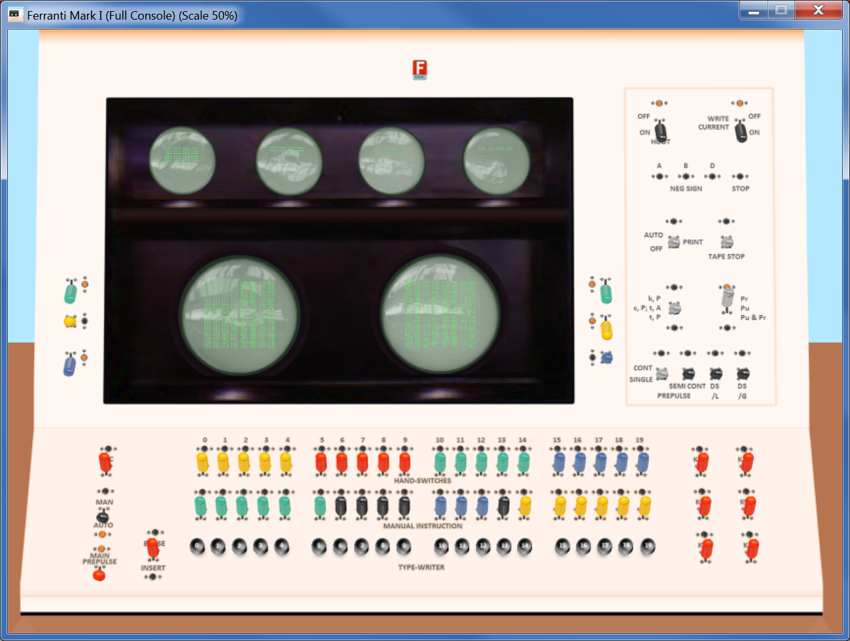

To close the control panel, use the command

sim> set cpanel off

## Available Control Panels

Several Control panels are selectable, Default one shows only the main CPU console.

Before issuing ***SET CPANEL ON***, it is possible to use ***SET CPANEL OPTION*** command to select the one to display

sim> att cpanel ../cpanel/MarkI.ini

sim> set cpanel option=Simplified

sim> set cpanel on

The ***SET CPANEL OPTION=*** ***Simplified*** will select a high-visibility simplified console. All in this console works exactly the same way as in regular photorealistic console.

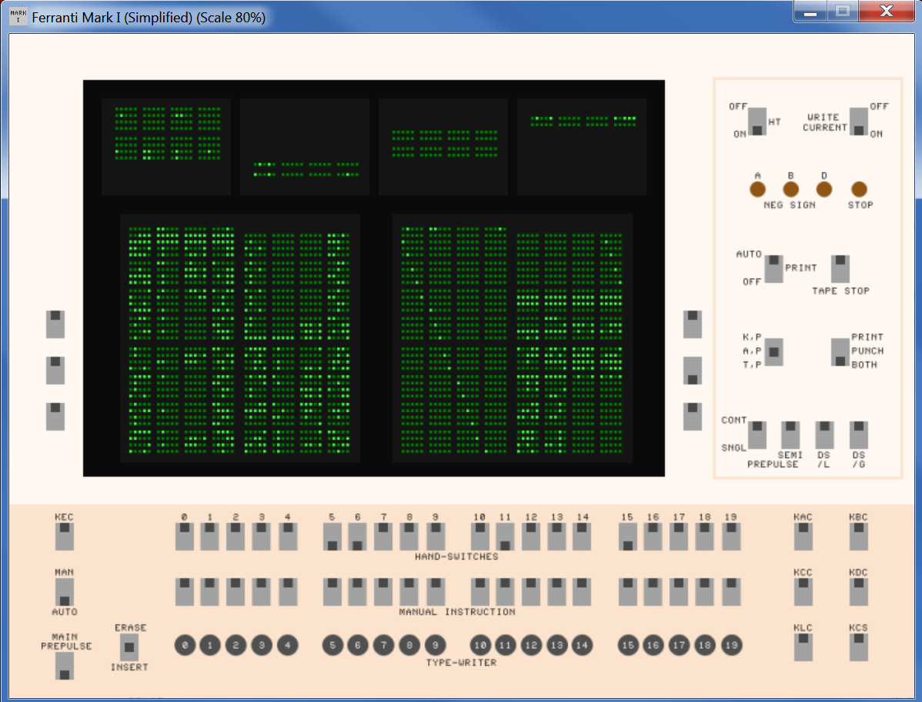

If no option is set, the full panel will be displayed

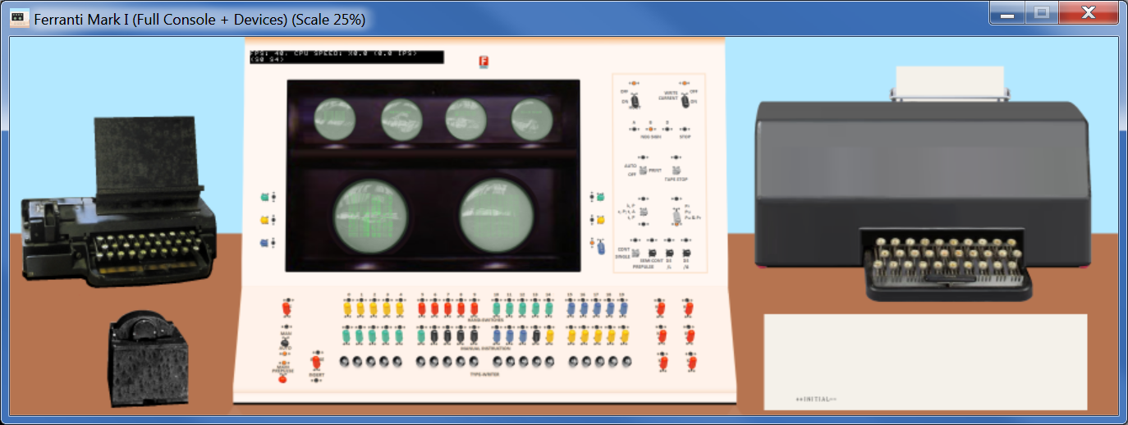

This panel includes images for (from top left to right) Creed Perforator, Paper tape Reader, Computer Console, and Creed TelePrinter.

You can explicitly select the default panel with ***SET CPANEL OPTION=All***

It is possible to select Creed 7P perforator (suitable for Brooker Autocode programs) instead of Regular Creed 6S

sim> att cpanel ../cpanel/MarkI.ini

sim> set cpanel option=Perforator/Creed7

sim> set cpanel on

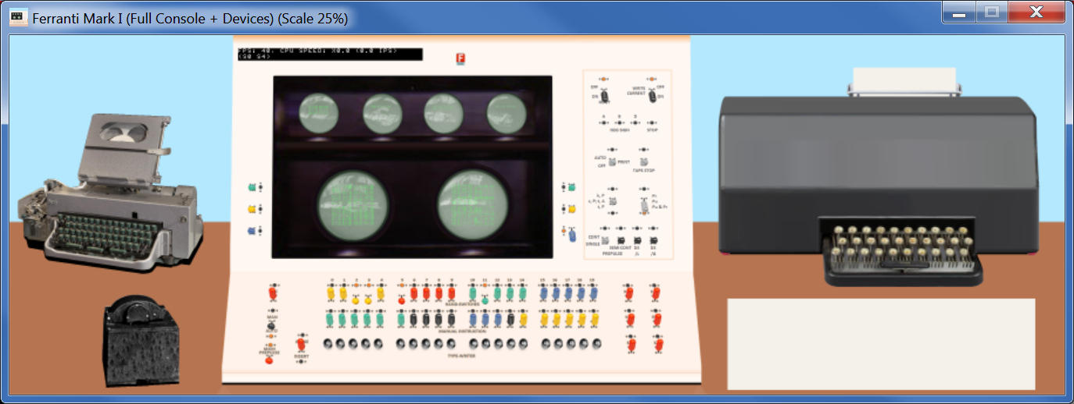

On photorealistic panels, it is hard to see the data on Scope Tubes because of the reflections of ambient light (as it was back in times). You can turn the lights off by selecting the Dark Mode for improved visibility:

sim> att cpanel ../cpanel/MarkI.ini

sim> set cpanel option=Perforator/Creed7

sim> set cpanel option=Dark

sim> set cpanel on

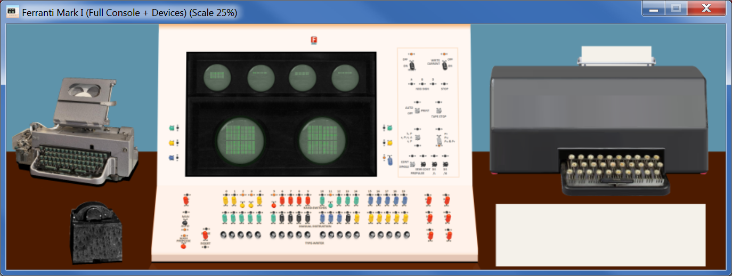

Dark mode can be selected/deselected at will (see later), and is available of all panels:

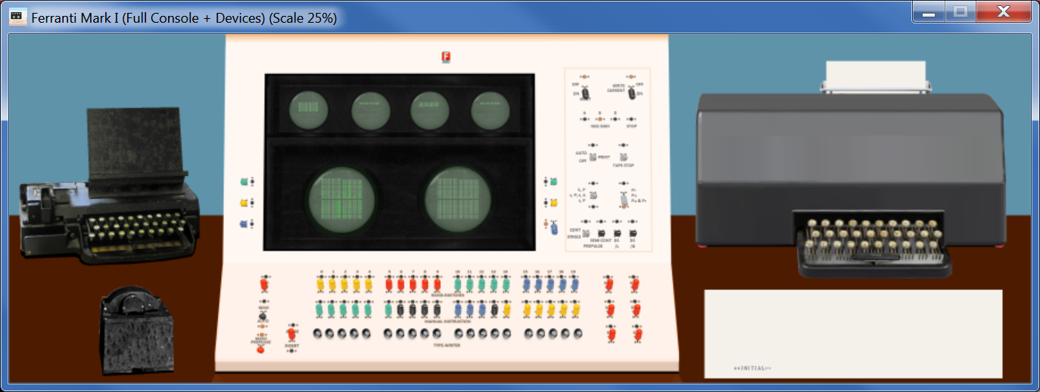

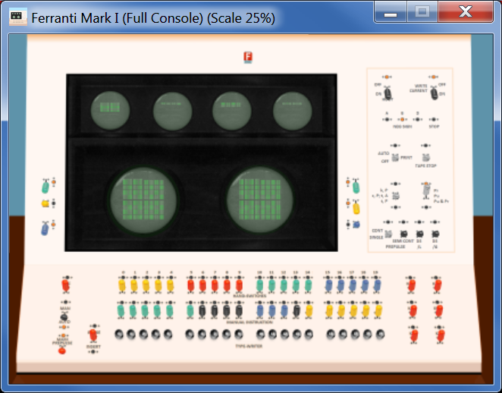

Important: To be effective, the SCP commands ***SET CPANEL OPTION*** must be set after ***ATTACH CPANEL*** command, but before ***SET CPANEL ON***.

## Control Panel size and position

As Control Panel includes more hardware, its size gets bigger. CPU console is 1700x1230 pixels and barely fits on screen. But All devices panel needs 3600 pixels wide.

To allow a comfortable display it is possible to set the scale on which the Control Panel GUI window will show the Control Panel.

sim> att cpanel ../cpanel/MarkI.ini

sim> set cpanel option=All

sim> set cpanel scale=50

sim> set cpanel on

This will display the control panel at 50% of its original size.

Allowed scales ranges from 10 (10% of original size) up to 200 (double of original size)

At any moment it is possible to move the Control Panel window with the mouse, as any regular window. But also it is possible to set the position of window with a command. This is handy to assure the position of Control panel is a good one given its scale when preparing a SCP script.

sim> att cpanel ../cpanel/MarkI.ini

sim> set cpanel option=All

sim> set cpanel scale=50

sim> set cpanel pos=50/100

sim> set cpanel on

Will set the Control Panel on screen coordinates x=50, y=100. Coordinates can be negative.

***SET CPANEL SCALE*** and ***SET CPANEL POS*** should be issued after **ATTACH CPANEL**.

If they are issued before first ***SET CPANEL ON***, they determine the initial position and scale that will be used on panel first appearance.

If they are issued when panel is already visible (after first ***SET CPANEL ON***), they will change the current position and scale.

SCP command ***ATTACH CPANEL*** sets initial scale to 100 (i.e the original size) and initial position to 90/50.

## Control Panel HotKeys

There are several HotKeys, that can be pressed while the Control Panel Window has the focus.

|  |  |
| --- | --- |
| **HotKey** | **Description** |
| **Control E** | Halts the simulation (same as Control E issued on SimH console) |
| **Control Y** | Toggles size of window between 100% and 50% (full size/half size) |
| **+**  **Control +** | Increases size of window a 10% (maximum 200%)  Increases size of window a 1% |
| **-**  **Control -** | Decreases size of window a 10% (minimum 10%)  Decreases size of window a 1% |
| **Control T** | Toggles mark on clickable areas of control panel |
| **Control I** | Toggles show Info |
| **Control F** | Fast Mode: while pressed, simulated CPU runs at maximum speed. When releases, CPU returns to its selected speed. |

### Control T – Toggle Marks

**Control T** will show an alternate green-red-flashing box on clickable control in the control panel. This eases to identify what can be used, and what cannot.

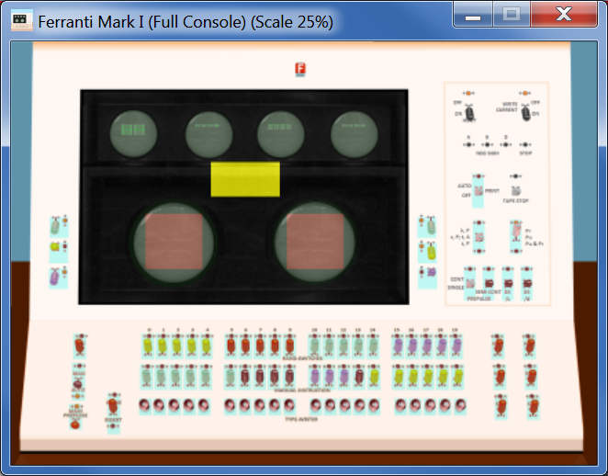 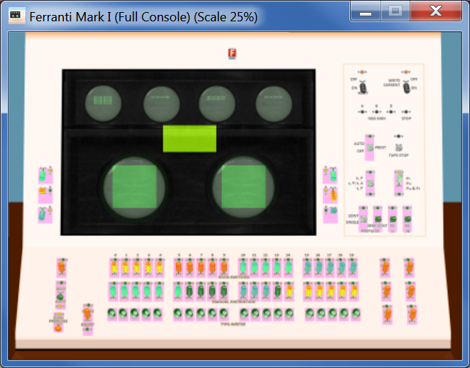

Also the areas where a file can be dropped are marked (See section “Drag and Drop files” bellow):

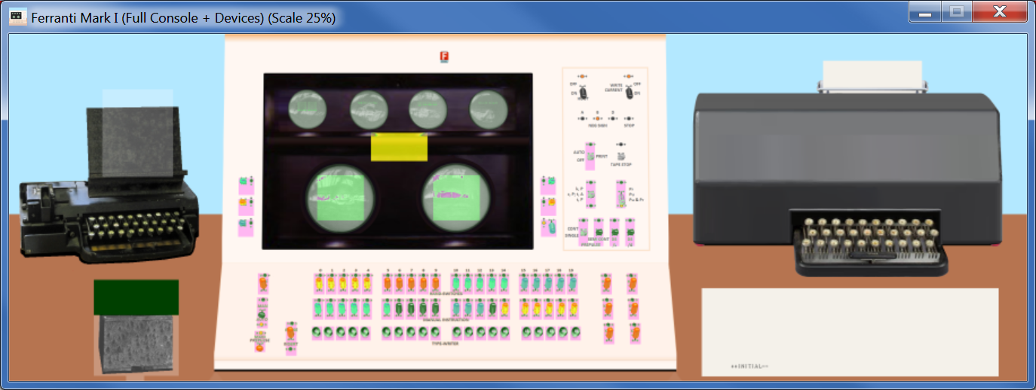

Drop Routine text file here to process it

Drop tape file here to mount it

### Control I – Show Information Panel

**Control I** will show an information panel with some internal simulator state on real time. Pressing again Control I will hide the info

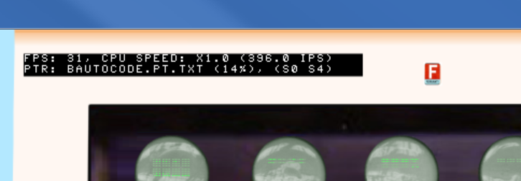

This information panel display:

* The current Frames Per Second (FPS) refresh rate
* The current measured CPU speed: in the example, x1.0 speed relative to original hardware. 396 are the Instructions per Second (IPS) being executed.
* The paper tape file name currently attached to reader
* The % of this tape already read
* The store tubes currently visible (S0 and S4 in the example)

### Control F – Fast Mode

**Control F** will accelerate the CPU speed while pressed.

This is very handy to speed slow operations on the fly, for example the paper tape reading operation.

|  |  |
| --- | --- |
| X1.0 speed | Control F |
|  |  |

The CPU acceleration will continue until

* The user releases Control F keys
* Simulator executes ***SET CPU SPEED*** command (e.g. on the script being run). In this case, the new CPU speed figures are recalculated and CPU resumes at new speed setting. To accelerate the CPU it is necessary to press again Control F

## Control Panel usage

The clickable controls can be spotted with Control T hotkey. Buttons and switches works as stated on Programming handbook

Clickable controls:

 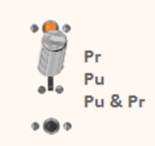 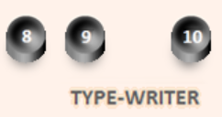 

2-way Switch 3-way switches Type-Writer Buttons Key-Switch

* 2-way Switch: will be stable in up or down position
* 3-way Switch: will be stable in up, center or down position
* Type-Writer buttons: pressed while left mouse button is being pressed
* Key-Switch: only stable in up position. Only in down position while left mouse button is being pressed. Notes:
  1. If you press Shift key in Host computer Keyboard while pressing mouse button, the simulated key-switch will remain in down position. This allows operating another switch while this one is kept hold down (see console operation section). Click again on key-switch to release it.
  2. On original HW, there were no visible differences between 2-way switches and Key-Switches. The Key-Switches are identified with a label that starts with “K”: KAC, KBC, KCC, KDC, KEC, KLC and KCS

The close top right box quits the simulation

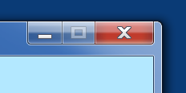

When CPU is running (thus the control panel is refreshed and responsive), the mouse pointer will be an arrow. If the pointer is placed on a clickable control, it will be changed to a hand

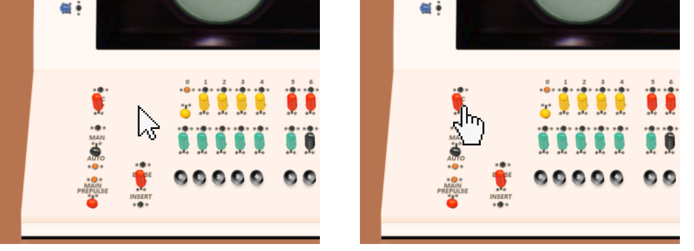

If the user clicks on control panel and moves the mouse without releasing the mouse button, then the control panel window will be moved on screen.

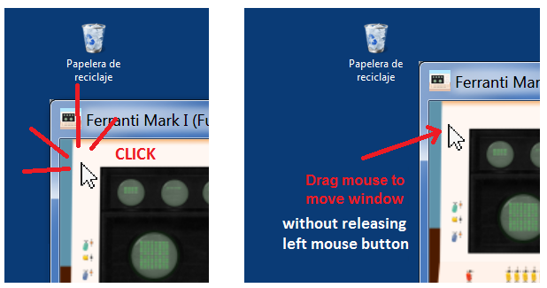

This is very handy when control panel window is zoomed and does not fit on screen.

When moving the Control Panel window by dragging the title bar (the standard move procedure), the GUI image stop being updated but the simulation still running. When moving the window by clicking in the image and dragging the mouse, the GUI image will not freeze and will be updated as the windows moves.

Control Panels can be big. With + and – hotkeys it is easy to resize the window at will. But when size is small, it can be difficult to read keys/switches labels.

On clicking on right mouse button, a tooltip will popup with showing the control panel image under the mouse at 100% scale.

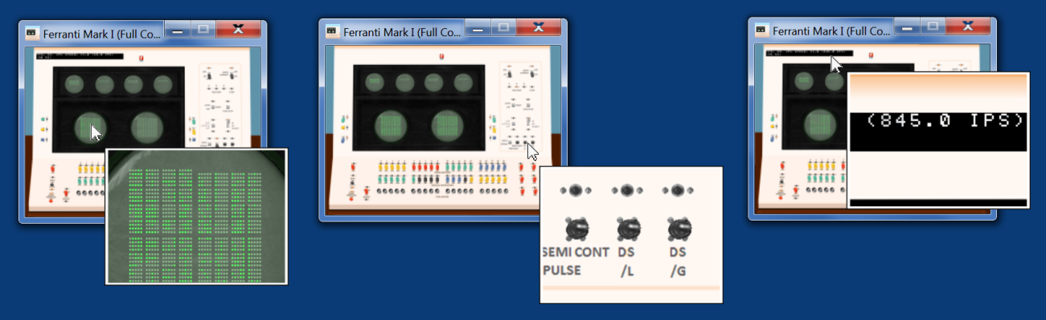

Dragging the mouse over the window while right button is kept pressed will show the contents on tooltip as mouse moves.

The tooltip window is closed automatically moving the mouse over it.

## Interactive Mode

When simulated CPU is running, control panel is active: shows info and reacts to mouse clicks.

During user console input at sim> prompt, two cases are possible:

* On non-windows platforms: during user console input at prompt, SimH is blocked waiting user to type a command and press enter. Thus the whole control panel is not responsive to mouse clicks, not responsive to window close button, nor is updated. This situation is signaled to the user by the slashed red circle mouse cursor shape.

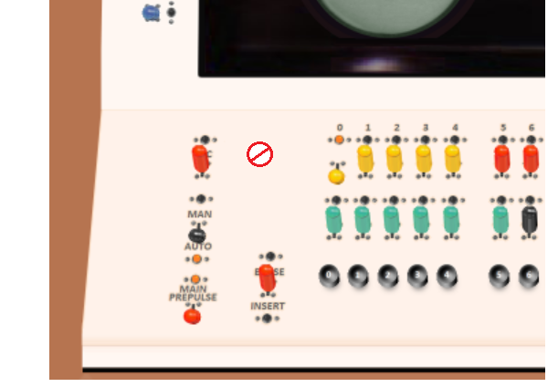

* On Windows: during user console input at prompt SimH is waiting user to type a command and press enter, but control panel is refreshed and active. Buttons/Switches/keys are sensed and works. Clicking on the close button of GUI windows exits SimH. Any SCP command issued as result of button/switch/key press on cpanel will be printed on console and executed as if it was typed by user

If SCP command ***SET CPANEL INTERACTIVE*** is issued, SimH transfer the control of simulation from SCP command line to control panel. SimH then refreshes control panel and responds to mouse in the same way as when CPU is running. This allows to control the simulation from control panel as in the real computer. CPU can be started and stopped while into interactive mode.

When in interactive mode, no SCP command can be typed on console, as ***SET CPANEL INTERACTIVE*** command still in execution. To terminate interactive mode and regain control on console, the user can either

* press **Control E** on console or on Control Panel window (or any other defined as WRU character)
* Press **Enter** on console

## Drag and Drop files

It is possible to send a Routine Program Sheet text file to Perforator using drag and drop feature of GUI.

To send file to perforator

* Select text file file. Can be either a Machine Programme Sheet or an Autocode Program
* Drag it to the perforator top area
* Drop the file in the drop area
* An animation will show a paper sheet on the GUI for few seconds as the file is being processed
* The animation will end restoring the default perforator apearence
* On the same folder of dropped file, a new file paper tape text file will appears, with extension “.pt.txt”

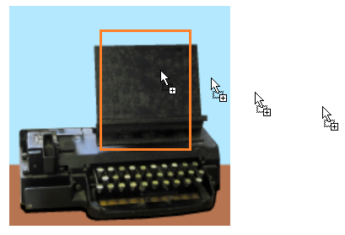 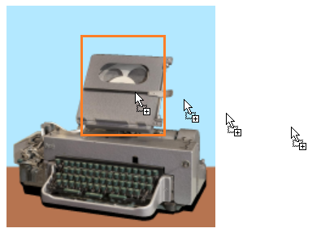

File being dragged

Drop file area

To mount (attach) a paper tape file to reader

* Select the paper tape text file
* Drag it to the reader
* Drop the file in the drop area
* A paper tape image will be shown, as tape is mounted and pending to be read

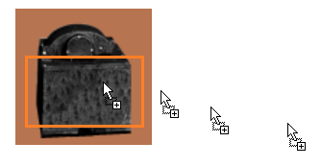 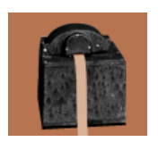

Paper tape mounted and ready to be read

Drop file area

File being dragged

## Detach tape file

To detach the current attached paper tape file (i.e unmount the tape currently mounted), just ciick on the top head of reader box

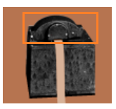

Click in this área to unmount paper tape

## Dark Mode

Dark Mode can be set via SCP command (at sim> prompt or in a script). The user can also toggle on/off dark mode just by clicking between the scopes

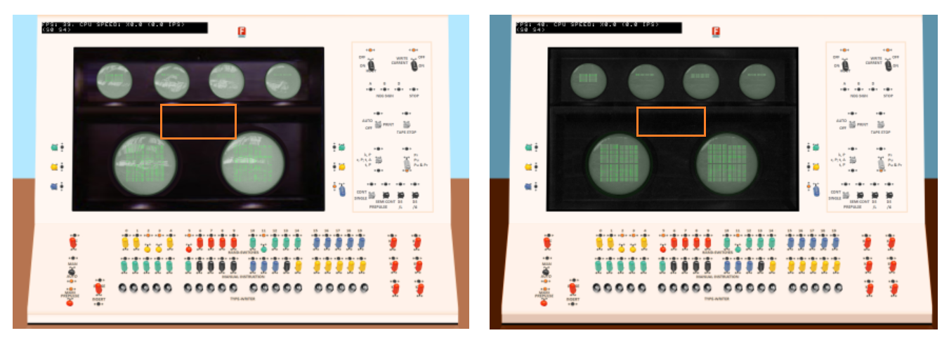

Click here to toggle on/off Dark Mode

## Store Selection

Big Left and right tubes will display the bit contents of selected memory store. The selection switches are located to the left/right of the tube,

As a nice unrealistic feature, it is possible to select next store to be displayed just by clicking in the tube image. The store will cycle S0 -> S1 and so on, up to S7, to return back to S0.

When changing the displayed store by clicking the tube, the selection switches on left/right and will be automatically updated to reflex the current store being shown. Also as a nice reminder, info panel will state store number.

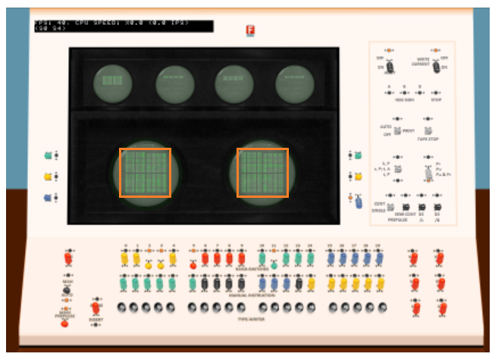

Click here to display next store contents

## Additional comments

### Speed Measurement

The speed measurement show on info panel (Control-I) is not the same as the one obtained with ***SHOW CPU SPEED***.

Show CPU speed command measures the speed along all the run, that is, from the moment that simulated has been started until the moment the simulated CPU is stopped

On information panel, the speed is measured on the fly. Control F boosts the measured speed, that returns to its normal (selected) value when Control F key is released

# Control Panel usage

## Mark I Console

Generally speaking, switches are active on down position, inactive in up position. When active, a light signals it.

### Scope Tubes

**Accumulator**

AL register (40 bits)

AM registers (40 bits)

**C (control)** register (20 bits)

PI registers (20 bits)

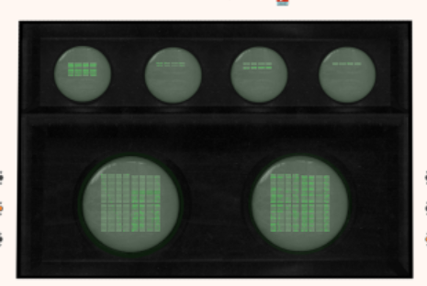

**D** Multiplier register (40 bits)

Memory Store

Memory Store

**B index** registers (8 x 1 line of 20 bits each)

### Store Display Selection

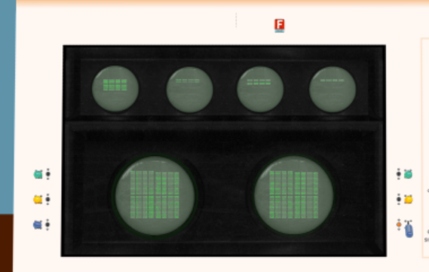

The boxed switches will select the memory store to be displayed in Left and Right (big) Scope Tubes. Green switch is bit0, yellow is bit1, Blue is bit2. Up position means zero, down means one.

In the image, left tube is set to store zero, right is set to store 4.

### Indicator lights

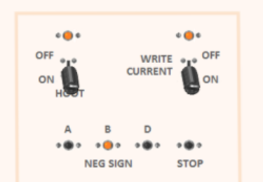

Lit when CPU halted on /L or /G instruction

Lit when AM, Last accessed B index or D are negative

Drum write on/off (not implemented,

always on)

Hoot control (not implemented)

(allways on)

### Input/Output control

Halts the tape punch

(not implemented)

**Auto**: teleprinter enabled.

**Off**: printing disabled

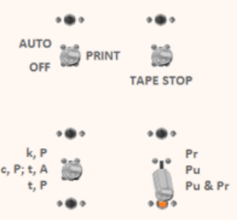

**k,P**: teleprinter keyboard enabled

**c,P; t,A**: teleprinter controlled by program

**t,P**: tape to teleprinter dump

**Pr**: just prints

**Pu**: just punch

**Pu & Pr**: print on teleprinter and punch in paper tape output characters sent from program

When switch set in “k,P” position AND the CPU is stopped, then user can press A..Z, 0..9 keys on host keyboard (while control panel GUI window has the focus): these keys will be printed in TelePrinter. This was the (completely manual) way to add textual comments to program output

When switch set in “t,P” position AND the CPU is stopped AND MAN-AUTO switch in “MANUAL” position, then the tape attached (if any) will be dumped to printer (see how to print a paper tape)

### Execution control

**SEMI CONT**: Semi-Continuous prepulse: when switch is down, CPU runs at 50 intructions per second speed

**CONT**: Continuous prepulse: run at full speed

**SINGLE**: Single prepulse set: execute only one instruction

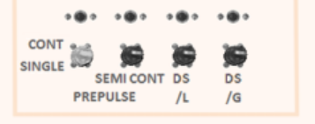

**Dummy Stop /L /G**: when switch is down, the /L /G instructions halts the CPU

### Hand Switches

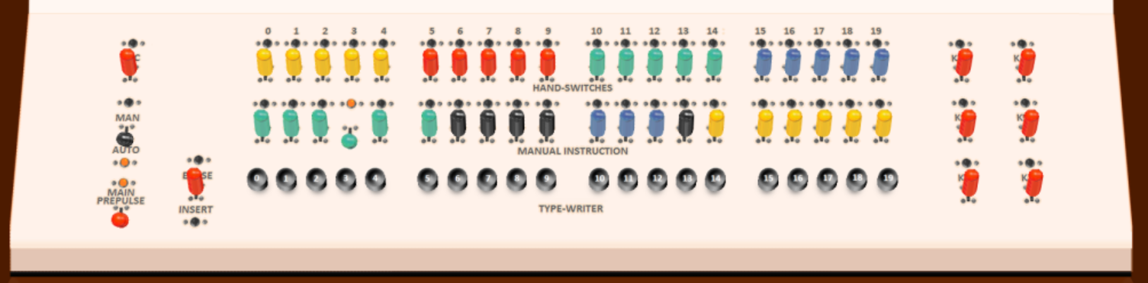

These are 2-way switches. Down position means value 1, up position means 0.

### Clearing Keys



**KCC**

**KDC**

**KBC**

**KAC**

**KEC**

Unfortunately, the label text is hidden by the switch because the way text label is printed in console.

The aim of these keys is to clear (set to zero) CPU register and memory

All these are Key-Switch: they are only stable in up position, when they are not active. The user can activate the Key-Switch bringing it down by clicking (left mouse button) on it. They only stay in down position while mouse button is being pressed.

Description ok keys:

**KAC**: Key Accumulator Clear: clears accumulator, This is same as issuing

SET CPU KAC command

**KBC**: clears all the B-index registers

**KCC**: Clears C control register, PI register, and sets the CPU so C will be incremented

Before executing next instruction (so next instruction will be fetched

from address 0001)

**KDC**: Clears D register

**KEC**: Key Everything Clear: same as above, plus clears the whole store, D and Q sign

Bits. This is same as issuing RESET SCP command and SET CPU KEC command

If you press Shift key in Host computer Keyboard while pressing mouse button, the simulated key-Switch KAC..KEC will remain in down position (and active clearing). This allows to operate another switch while this one is kept held down (se console operation section). Click again Key-Switch to release to its inactive stationary up position.

### Instruction execution keys



**KCS**

These keys allows to start, stop, execute one, resume instruction execution

**MAN-AUTO**:

* + When in AUTO position, CPU fetches instructions to execute from address in C register. CPU also and increments C on instruction execution termination.
  + When in MANUAL position, CPU fetches instructions to execute from **MANUAL INSTRUCTION** switches. CPU does not increments C on instruction execution termination.

**MAIN PREPULSE**:

* + When in **down** position MAIN PREPULSE is active. CPU will execute the instructions following the rate given by CONT/SINGLE and SEMI CONT switches.
  + When in **up** position MAIN PREPULSE is not active. CPU is halted

**KCS**: Key Competition Signals. This is also a Key-Switch only active while being clicked. When clicked down, resumes the execution of current halts instruction:

* + Resumes execution of /L /G instruction that halted the CPU because Dummy Stop /L or /G switch was active
  + If a Paper Tape Read instruction halts the CPU because no paper tape mounted or paper tape is exhausted: mount new paper tape in reader (either with SCP command or dropping a file to reader) and then press KCS to resume paper tape processing
  + If CONT/SINGLE switch in SINGLE position, clicking KCS will step one program instruction (MAIN PREPULSE should be down, in active position, AUTO/MAN switch in AUTO position)
  + If CONT/SINGLE switch in SINGLE position, AUTO/MAN switch in MANUAL position, clicking KCS will execute once the instruction set in MANUAL INSTRUCTION switches, without altering C. This allows to stop CPU and then manually execute instructions, and then resume the program, see how to section.

Note that AUTO/MAN switch in MAN position, but If CONT/SINGLE switch in CONT position, the instruction set in MANUAL INSTRUCTION switches will be executed repeatedly. This was intended for the Ferranti Maintenance Engineers. It has no much sense for the user/programmer.

### Type-Writer keys

**Address part of MACHINE INSTRUCTIONS**



**ERASE/INSERT**

**KLC**

These keys allow to manually enter data in Store memory. MAN/AUTO switch must be in MANUAL position in order to enable type-writer and KLC keys.

The address to use is set on the **address part** of MACHINE INSTRUCTIONS switches

**KLC**: Key Line Clear. This is a Key-Switch only active while being clicked.

* + When clicked down, clears (set to zero) the 20 bits line at address set on the address part of MACHINE INSTRUCTIONS switches

**ERASE/INSERT**: This is a 3-way switch. Default is center position (no operation)

* + When switch in INSERT position (switch down), pressing a **type-writer key** will toggle between 0 and 1 the corresponding bit at address set on the address part of MACHINE INSTRUCTIONS switches
  + When switch in ERASE position (switch up), pressing a **type-writer key** will set to 0 the corresponding bit at address set on the address part of MACHINE INSTRUCTIONS switches

## How To …

### Reboot Scheme A

1. Set MAIN PREPULSE to inactive position (switch up) to stop CPU
2. Set all HAND SWITCHES to zero (all in up position)
3. Press KEC to reset the computer and clear all
4. Set MAIN PREPULSE to active position (switch down) to start CPU
5. The computer then will
   1. Increment C. It was cleared, so C gets value 0001
   2. Fetch first instruction to execute for C address (0001). As memory also has been cleared, this instruction is 0 (coded //// with TelePrinter chars)
   3. Execute //// instruction. This instruction is “obey H as magnetic instruction”
   4. H is set to 0. It is interpreted as “Operation 0 (Read) from track 0 to Store memory S0. This will load the INITIAL routine from SchemeA to memory, store S0
   5. CPU will then increment C (now its value is 0002) and the execute INITIAL code, that loads PERM and INPUT
   6. The welcome message will be printed

++INITIAL--

* 1. The computer will read the Paper Tape Reader for warning characters sequence to execute. Will stop if no tape file attached to reader.

1. Mount a paper tape either by dropping a file in the reader
2. Press KCS to resume execution. The computer will now read and process the paper tape file

### Resume from Stop

1. Press KCS to resume execution. Will stop on next Dummy Stop unless the corresponding DS /L or DS /G switch is set to inactive position (up position)

### Step a program

1. Set MAIN PREPULSE to inactive position (switch up) to stop CPU. This will halt CPU at beginning on next instruction. C register will indicate the address of next instr to execute. PI will indicate last instruction executed
2. Set CONT/SINGLE to SINGLE position to execute instructions on a one by one basis
3. Press KCS to execute next execution.
4. Press KCS multiple times to step instructions
5. When done, revert console state
   1. Set CONT/SINGLE to CONT position to select full speed execution
   2. Set MAIN PREPULSE to active position (switch down) to start CPU

### Modify a memory word (method 1)

1. Set MAIN PREPULSE to inactive position (switch up) to stop CPU
2. Select the Store tube to modify to be visible either in Left or Right tube
3. Set MAN/AUTO to MANUAL position to enable type-writer buttons
4. Set the address to modify in address part (bits 0 to 8) of MANUAL INSTRUCTION switches. (Remember to use binary backwards. Least significant bit is leftmost one. Switch up means 0, switch down means 1).
5. Set the ERASE/INSERT switch in INSERT position
6. Press Type-Writer buttons to toggle bits on/off. Press KLC at any moment to clear the whole line
7. Goto step 4 to modify another word of memory.
8. Revert console state
   1. Set the ERASE/INSERT switch in center position
   2. Set MAN/AUTO to AUTO position
   3. Set MAIN PREPULSE to active position (switch down) to start CPU

### Modify a memory word (method 2)

1. Set MAIN PREPULSE to inactive position (switch up) to stop CPU
2. Select the Store tube to modify to be visible either in Left or Right tube
3. Set CONT/SINGLE to SINGLE position to execute instruction once
4. Set MAN/AUTO to MANUAL position to enable manual instruction
5. Set the bit 10-14 to zero, 16-18 to 0, bits 15 and 19 to one. This is the instruction /Z that is “S=H”: copy contents of Hand switches to store
6. Set the address to modify in address part (bits 0 to 8) of MANUAL INSTRUCTION switches.
7. Set the new value to store in HAND-SWITCHES
8. Press KCS to execute the manual instruction. This will store the value of hand switches to selected address
9. Goto step 6 to modify another word of memory.
10. Revert console state
    1. Set MAN/AUTO to AUTO position to enable manual instruction
    2. Set CONT/SINGLE to CONT position to select full speed execution
    3. Set MAIN PREPULSE to active position (switch down) to start CPU

### Manual print on TelePrinter using its keyboard

1. Set MAIN PREPULSE to inactive position (switch up) to stop CPU
2. Set k,P/t,A/t,P switch to k,P position
3. Type on host keyboard. The characters will be printed on TelePrinter
4. When done, revert console state
   1. Set k,P/t,A/t,P switch to t,A position
   2. Set MAIN PREPULSE to active position (switch down) to start CPU

### Print a paper tape on TelePrinter

1. Set MAIN PREPULSE to inactive position (switch up) to stop CPU
2. Set MAN/AUTO to MANUAL position to enable tape dump
3. Remove any tape attached to paper tape reader, by clicking on its top head
4. Mount paper tape to be printed by dropping the file in paper tape reader image
5. Set k,P/t,A/t,P switch to t,P position. The printer starts to print the tape contents
6. You can stop/resume printing by changing the setting of k,P/t,A/t,P switch
7. When done, revert console state
   1. Remove any tape attached to paper tape reader, by clicking on its top head
   2. Set k,P/t,A/t,P switch to t,A position
   3. Set MAN/AUTO to AUTO position
   4. Set MAIN PREPULSE to active position (switch down) to start CPU

### Read a Track from Drum to Memory Store

1. Set MAIN PREPULSE to inactive position (switch up) to stop CPU
2. Select the Store tube to modify to be visible either in Left or Right tube. In this example, store S0 and S1
3. Set CONT/SINGLE to SINGLE position to execute instruction once
4. Set in HAND-SWITCHES the bit 8-10, 12-19 to zero, bit 11 to one. This is the magnetic instruction //@/ (read full track to stores S0 and S1)
5. Set in HAND-SWITCHES the track number to read-in using bit 0-7
6. Click on KCC switch, while HOLDING DOWN shift key on computer host keyboard. This will simulate keeping KCC down
7. Press KCS while KCC still down. This forces the computer to exec instruction //// (obey H as magnetic instruction) and thus read from drum to stores.
8. Click again KCC to release it
9. The data read is visible on console scopes Left and Right

### Write Memory Store to Drum Track

1. Set MAIN PREPULSE to inactive position (switch up) to stop CPU
2. Set CONT/SINGLE to SINGLE position to execute instruction once
3. Set in HAND-SWITCHES the bit 8-10, 12, 14-19 to zero, bit 11 and 13 to one. This is the magnetic instruction //R/ (write stores S0 and S1 to a drum track)
4. Set in HAND-SWITCHES the track number to write-to using bit 0-7
5. Click on KCC switch, while HOLDING DOWN shift key on computer host keyboard. This will simulate keeping KCC down for 10 sec
6. Press KCS while KCC still down. This forces the computer to exec instruction //// (obey H as magnetic instruction) and thus write stores to drum.
7. Click again KCC to release it

### Run Love Letters program

|  |  |  |
| --- | --- | --- |
| Action to do in real hardware | | Equivalent GUI control to use |
| 0 | Power Up the computer, prepare the Love Letters tape | From Windows file Explorer, double click on  run CPanel MarkI - Love Letters (1952).bat  to execute it: |
| 1 | Loads the program tape and runs it. The computer prints a nice Love Letter |  |
| 2 | Run again | Press KCS to run again and generate a new love letter |

### Run Draughts Game program

|  |  |  |
| --- | --- | --- |
| Action to do in real hardware | | Equivalent GUI control to use |
| 0 | Power Up the computer, with Draughts Game resident in Drum | From Windows file Explorer, double click on  run CPanel MarkI - Draughts Play.bat  to execute it: |
| 1 | The computer welcomes the human player | Enlarge the control panel GUI window by clicking on it and  pressing + (plus) or – (minus) key |
| 2 | And does its first move | Left tube will show board position before move,  Right tube show current board state: |

|  |  |  |
| --- | --- | --- |
| 3 | The human should move | Each board cell gets a number  A move is described giving the number of origin cell and destination cell. At first program move from cell 8 to cell 13 (printed as 8 – 13)  We use Hand Switches to enter each digit pair, the we operate KAC to enter the value (keep KAC pressed a bit of time, if pressed and released too fast computer does not detect it)  +  Now we will nove from 23 to 18:    The sequence can have more than two digit pairs if we make several hops eating some computer pieces.  To end the sequence, enter 0 value:    Now it is the turn of the computer  Note: To re-enter last digit pair, set all hand-switches to 0, except bit 19 witches is set to 1; then press KAC. Now enter again a digit pair.  For more info, read excellent paper on Draughts by David Link at <https://www.computerconservationsociety.org/resurrection/res60.htm#f> |

### Run an Autocode program

|  |  |  |  |
| --- | --- | --- | --- |
| Action to do in real hardware | | Equivalent SCP command | Equivalent GUI control to use |
| 0 | Power Up the computer, with Autocode compiler resident in Drum | From Windows file Explorer, double click on  run CPanel MarkI - Brooker Autocode (1955).bat  to execute it: | |
| 1 | Punch the Autocode program paper tape by typing-in the source code in Creed 7P perforator | ***attach -n Perforator Sample/Sieve.ba.pt.txt***  ***typein BAutocode source Sample/Sieve.ba.txt*** | Sieve.ba.txt file is located in  ./sw/Brooker_Autocode/Sample folder  Drag and drop autocode source file  to Creed 7P perforator |
| 2 | Get the punched paper tape from perforator | ***detach -q Perforator*** | The punched paper tape file is automaticaly  created next to source autocode program  (same name, extension .pt.txt) |
| 3 | Mount the paper tape in Reader | ***attach ptr Sample/Sieve.ba.pt.txt*** | Drag and drop paper tape file  to reader |
| 4 | Click on KLC Key-Switch to start  Autocode compiler | ***go*** | Click on KLC Key-Switch to start  Autocode compiler |
| 5 | The computer runs the program and prints the results |  |  |

Prints prime numbers <= 200 using Sieve of Eratosthenes

### Run HelloWord Scheme A program

|  |  |  |
| --- | --- | --- |
| Action to do in real hardware | | Equivalent GUI control to use |
| 0 | Power Up the computer, with Scheme A resident in Drum | From Windows file Explorer, double click on  run CPanel MarkI - Scheme A (1951).bat  to execute it: |
| 1 | Punch the HelloWorld paper tape by typing-in the source routine in Creed 6S perforator | HelloWorld.txt file is located in  ./sw/SchemeA/Sample folder |
| 2 | Get the punched paper tape from perforator | The punched paper tape file is automaticaly  created next to source routine program  (same name, extension .pt.txt) |
| 3 | Display stores S4 and S5 in scopes | By clicling in the selection swtiches. Set also Dark Mode and GUI Windows size for improved visibility |
| 4 | Mount the paper tape in Reader | Drag and drop paper tape file  to reader |

|  |  |  |
| --- | --- | --- |
| 5 | Click on KLC Key-Switch to start Scheme A INPUT |  |
| 6 | The paper tape will be read, the program loading progress will be visible on scopes |  |
| 7 | Save Stores S4 and S5 to Drum Track 10 | 1. Set MAIN PREPULSE to inactive position (switch up) to stop CPU 2. Set MAN/AUTO to MAN position to execute manual instruction 3. Set CONT/SINGLE to SINGLE position to execute instruction once 4. Set all MANUAL INSTRUCTION switches to zero (up position) 5. Set all HAND-SWITCHES switches to zero (up position), except bits 1,3,11,13 and 18 witch are set to one. This is the magnetic instruction R/R# (write stores S4 and S5 to drum track 10)        1. Press KCS. The computer exec instruction //// (obey H as magnetic instruction) and thus write stores to drum. |

|  |  |  |
| --- | --- | --- |
| 8 | Prepare Steering Tape | 1. Create text file Steering.pt.txt, that contains the following line   K VS @ //// R/@/ Y  These are Scheme A warning character to   * + 1. Set the cue of routine to executed (K VS xxx)     2. Call in the routine (Y)      1. Click on top head of reader to detach the routine tape from reader |
| 9 | Mount the steering tape in Reader | Drag and drop file to reader |
| 10 | Restart  Scheme A | 1. Set MAIN PREPULSE to inactive position (switch up) to stop CPU 2. Set MAN/AUTO to AUTO position 3. Set CONT/SINGLE to CONT position 4. Set all HAND SWITCHES to zero (all in up position) |
| 11 | Run the steering tape to start the HelloWorld program from Drum | 1. Press KEC to reset the computer and clear all 2. Set MAIN PREPULSE to active position (switch down) to start CPU 3. Check the printer output |

Easy, isn’t it?

### Programs to Run

There are a set of already prepared .bat files that demoes the system in a fully automated way.

These batch files relies on .ini scripts, examine the scripts to understand what’s going on, and how to use the computer.

run CPanel MarkI - Brooker Autocode (1955).bat

run CPanel MarkI - Brooker Autocode Build .bat

run CPanel MarkI - Brooker Autocode Demo Sieve.bat

run CPanel MarkI - Draughts Build (1952).bat

run CPanel MarkI - Draughts Play.bat

run CPanel MarkI - Love Letters (1952).bat

run CPanel MarkI - Scheme A (1951).bat

run CPanel MarkI - Scheme A Full Printout.bat

run CPanel MarkI - Scheme A HelloWorld.bat

run CPanel MarkI - Scheme B (1952).bat

run CPanel MarkI - Scheme B Demo FloatCode.bat

run CPanel MarkI - Scheme C (1953).bat

run CPanel MarkI - Scheme T (1954).bat

run MarkI - Brooker Autocode Demo 1.bat

run MarkI - Brooker Autocode Demo 2.bat

run MarkI - Brooker Autocode Demo TPK.bat

run MarkI - Scheme A Build (1951).bat

run MarkI - Scheme A Demo.bat

run MarkI - Scheme B Build.bat

run MarkI - Scheme B Demo.bat

run MarkI - Scheme C Build.bat

run MarkI - Scheme C Demo 1.bat

run MarkI - Scheme C Demo 2.bat

“run CPanel MarkI” batch shows the different available control panels and runs at real HW speed.

“run MarkI” batch does not shows any control panel, runs in SimH text console at maximum speed allowed by host.

You can enjoy the Mark I already made sample programs and play & modify them files without the burden of manually starting a program from console.

# Version History

* **Release 1: Apr/2023**
* Hardware support:
  + Ferranti Mark I
  + Creed 6S/7P offline perforator
  + Paper tape Reader and Punch
  + Creed 7B TelePrinter
  + Control Panel GUI
* Software included:
  + Scheme A, Scheme B, Scheme C, Scheme T
  + Love Letters
  + Draughts
  + FloatCode
  + R.A. Brooker Autocode